Sheet 1 Answers
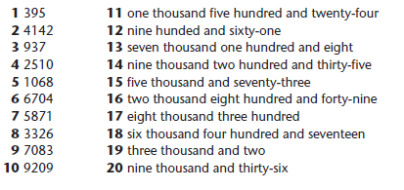
Check your answers and go back to any question you made a mistake on to try to puzzle out how to correct it.

