Thursday Activity: Round to 1,000,000
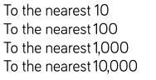
- Round 85,617

- Create the table and complete, rounding distances to the nearest 1000.

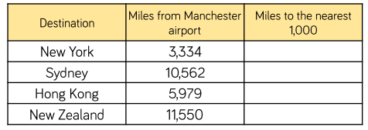

- Create the table and complete:
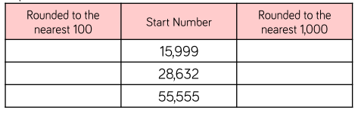

- Show your working out and answers:
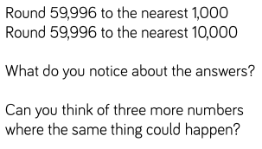

5) Show your working out and answers:
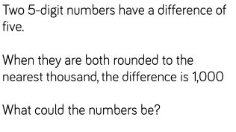

6) Create this table and complete, rounding to the nearest 100,000.
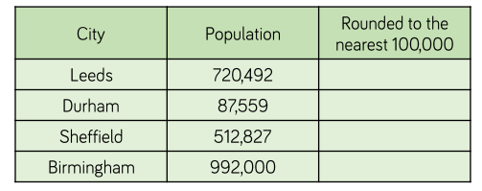

7) Round the number 450,985 to the nearest:
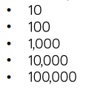

8) Show your working out and answer:
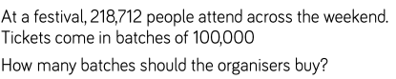

9) Show your working out and answers:
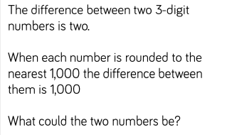

10) Show our working out and answers:
