Before you complete the worksheet on adverbials, remember that an adverbial phrase (group of words) or clause (group of words including a verb) can be used just like an adverb to add further detail about the action to a sentence.
They can be adverbials of place (where) e.g. She was waiting by the bus stop.
They can be adverbials of time (when) e.g. John brushed his teeth every morning.
They can be adverbials of manner (how) e.g. The dog ran as fast as it could.

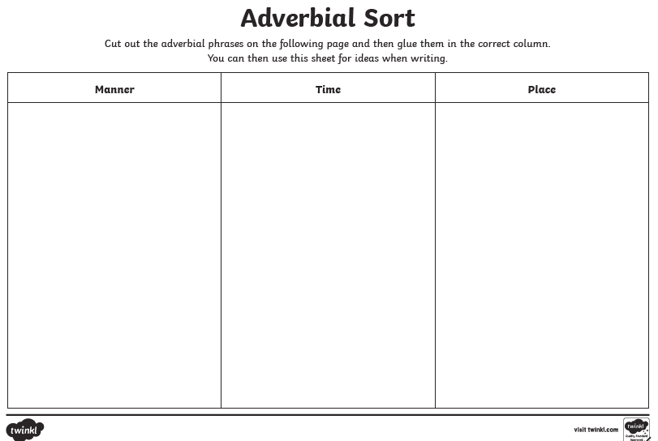
Copy out the 3 columns, then sort the adverbials on the next page into the correct column.

