Home Learning – English task break down
Monday:
Activity: Water Cycle
Watch this video: https://www.bbc.co.uk/bitesize/topics/zkgg87h/articles/z3wpp39
Now write me a definition for each of the following words: You can use the video to help you. If you want to, you could look the words up in a dictionary!
1. Evaporation –
2. Condensation –
3. Precipitation -

Tuesday:
Activity: Water Cycle – Part 2
Create a diagram of the water cycle. Copy the diagram below and then label it with the correct words.
Here is another video to help you! https://www.bbc.co.uk/bitesize/clips/z8qtfg8
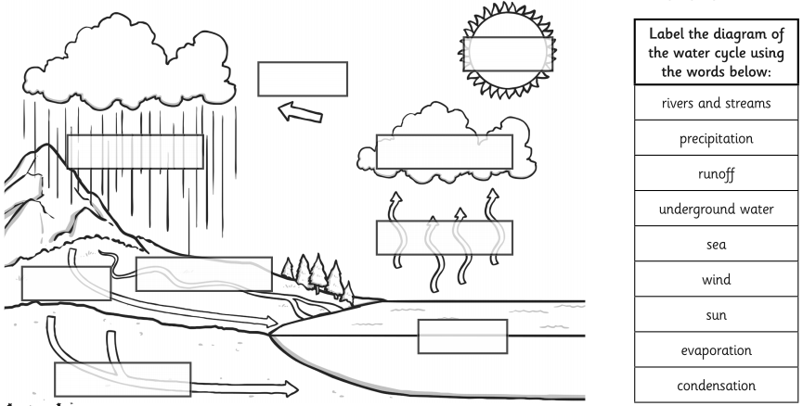
When you have completed your diagram and labelled it, use the diagram and your key words to write a paragraph to describe the water cycle.
Start like this:
Water from the sea is warmed up by the sun. As the water heats up…

Wednesday:
Activity: Rivers
Please follow the link and work through the webpage. There is a video followed by a short reading passage, another short video and a quiz!
https://www.bbc.co.uk/bitesize/topics/z849q6f/articles/z7w8pg8

Thursday:
Activity: Comprehension
Read the text below and then answer the following questions in full sentences.
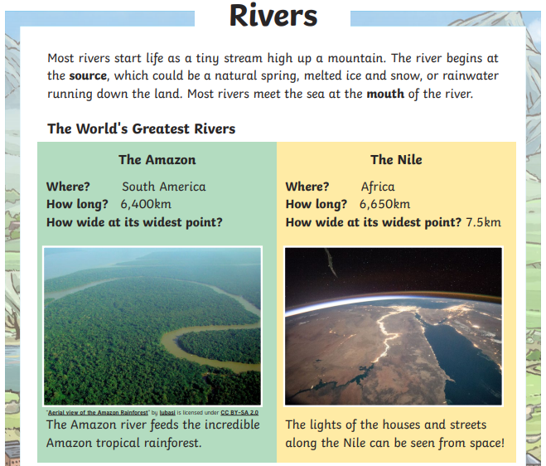
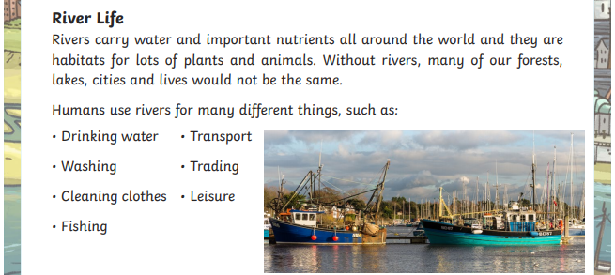
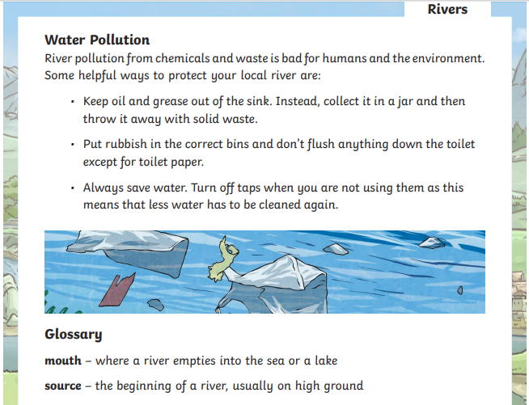
Questions:
- What is it called where the river meets the sea?
- Complete the sentence using the correct words from the text…
Rivers carry ___________ and important ______ all around the world and they are ______ for lots of plants and animals.
- What is the meaning of the word ‘source’?
- Which river is longer, the Amazon or the Nile?
- Name two ways in which humans use rivers.
- Find and copy one caption (text to accompany an image) from the text.
- The sub-heading ‘Water Pollution’ tells the reader what the next section of the text is about. Can you think of another sub-heading which could have been used?

Friday: Showbie
Activity: J.M.W. Turner
Here is a link for you to read a little bit about JMW Turner. He is well known for his paintings of scenes that included water… particularly the sea.
https://primaryfacts.com/5375/j-m-w-turner-facts-and-information/

Activity: Art (optional)
If you are able to, this is your chance to do some Artwork based on Turner and his paintings.
This could be:
- a plain pencil
- colouring pencils
- crayons
- paint
follow this link to see more examples of his paintings: https://www.nationalgallery.org.uk/artists/joseph-mallord-william-turner

If you want to get really creative, you could look at this link on expressive painting. https://www.bbc.co.uk/programmes/p0282x1z
I used it in the music project pack, but if you watch the video, you could always use this piece of music https://www.youtube.com/watch?v=2X7JDvTarqQ as inspiration. It is called ‘storm’ and is part of a longer piece of music called ’The Sea Interludes’ by Benjamin Britten.

Thursday Comprehension Answers
- Mouth.
- Water…nutrients…habitats.
- Answers which suggest that the source is the beginning of a river, usually on high ground.
- The Nile.
- Any of the following: drinking water, washing, cleaning clothes, fishing, transporting, trading, leisure.
- Accept any of the following:
- The amazon river feeds the incredible amazon tropical rainforest.
- The lights of the houses and streets along the nile can be seen from space.
- Fishing boats on the Lymington river on the south coast of England.
7. accept any subtitle which is short and appropriate.

