Question 1: **Who are Sikhs? What do they**

**believe about God?**

Activity: Watch the video clips below. What have you learnt about the Sikhs belief about God?

Resources:

<https://www.youtube.com/watch?v=qx6jOKCroBY>

Question 2: **What is the name of the Sikhs’ special books? How is it used within worship?**

What do Sikhs believe about the Guru Granth Sahib? Watch the video clip about the Guru Granth Sahib. Sikhs treat the Guru Granth Sahib with the greatest respect – why do you think this is? What do they do that proves this? Complete the grid below (Sheet 2).

Resources:

<https://youtu.be/h2LbTwwGsAY>

<https://www.bbc.co.uk/bitesize/clips/z9gkq6f>

Question 5: **Where is a special place for Sikh people? Why is Langar an important part of their religion?**

Activity:

Watch this clip <http://www.bbc.co.uk/education/clips/zvx6yrd>

Discuss: What happens in the langar? Where does the food come from, who prepares it? Who eats it? The Guru Granth Sahib is very clear in its instruction for all Sikhs to carry out Seva in a selfless and humble way.

Label the picture below. What does it show about Langar?

Resources:

<http://www.bbc.co.uk/education/clips/zvx6yrd>

<https://www.youtube.com/watch?v=qXhV3dMxSzE>

Question 3: What is a Kalsa Sikh?

Activity: What groups do you belong to? Why do you belong to these groups? How does it make you feel to belong? Anyone who follows the Sikh faith is a Sikh. But many Sikhs also go through a ceremony called Amrit (baptism) in which they are welcomed into a part of a Sikh society called the Khalsa. They then can wear the 5 symbols of the Sikh faith.

Resources:

Story of how the Khalsa began

<https://www.truetube.co.uk/film/formation-khalsa>

Create a short cartoon of the story. These men were willing to die for their faith and be truly committed to the teachings of the gurus. They became known as the 5 beloved ones and the first Sikhs to be part of the Khalsa.

<https://www.youtube.com/watch?v=JpFw7DqRMEc&list=PLcvEcrsF_9zLEkrjUn7s2E8wDNknt7yqp&index=8>

**Sikhism**

**Who is Sikh and what do they believe?**

Question 4: **What are the 5K’s?**

Activity: Watch and read the pdf about the 5 K’s. Then complete the worksheet below.

<https://www.youtube.com/watch?v=QYW10gv3jm0>

Twinkle PowerPoint

<https://www.twinkl.co.uk/resource/t2-r-011-sikhism-the-five-ks-powerpoint-and-worksheet-pack>

Additional sources of information to help with research.

<https://www.truetube.co.uk/film/alien-abduction-sikhism>

<https://www.twinkl.co.uk/resources/planit-religious-education-primary-teaching-resources/planit-religious-education-primary-teaching-resources-year-three/planit-religious-education-primary-teaching-resources-year-three-sikhism>

<https://www.bbc.co.uk/bitesize/topics/z8qxfg8/resources/1>

**Final Task:** Using the information you have learnt about Sikhism, create a poster or a fact file to teach your friends all about the Sikh Faith. Don’t forget to answer the big question: Who is Sikh and what do they believe?

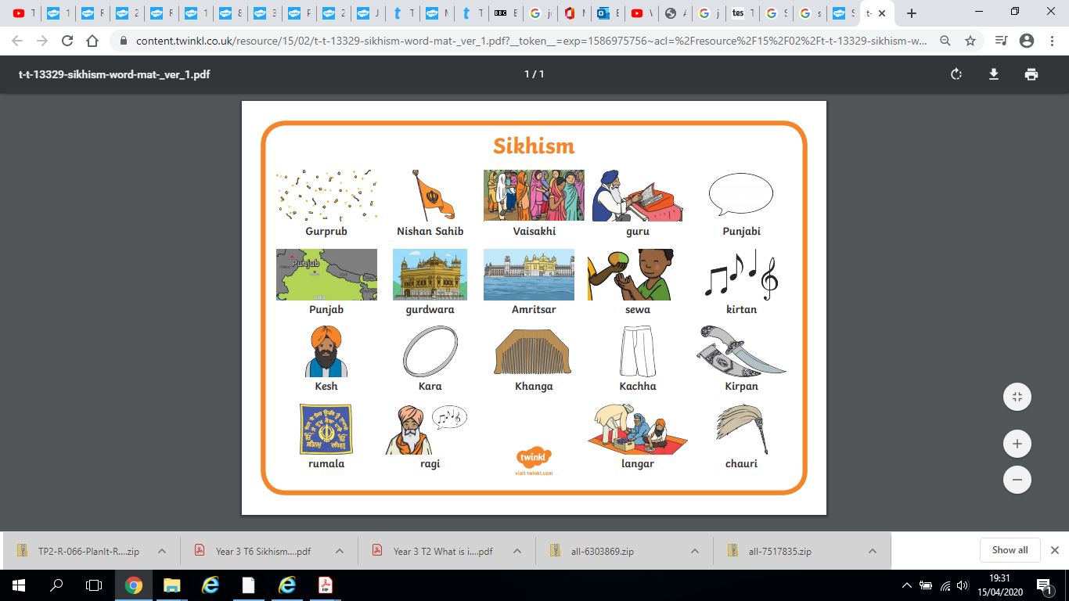

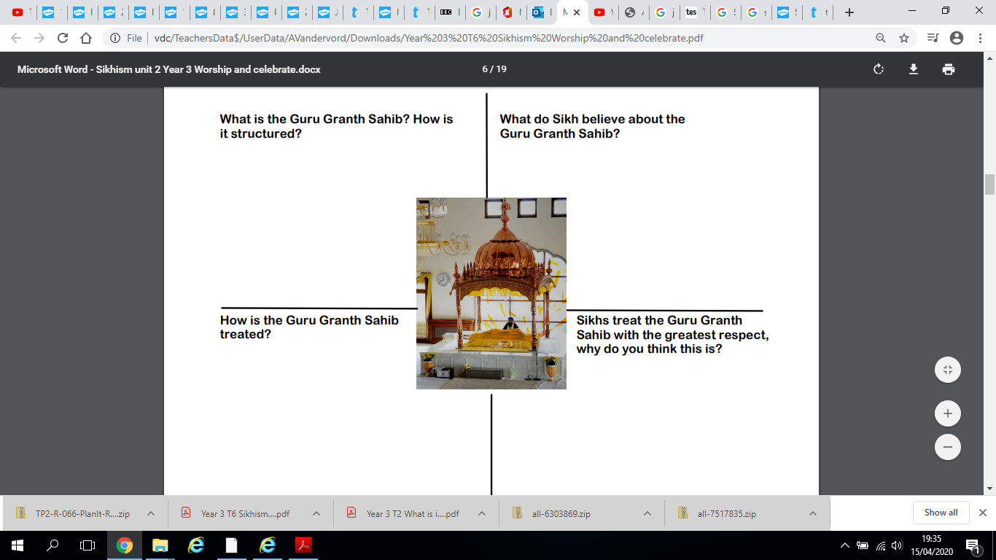

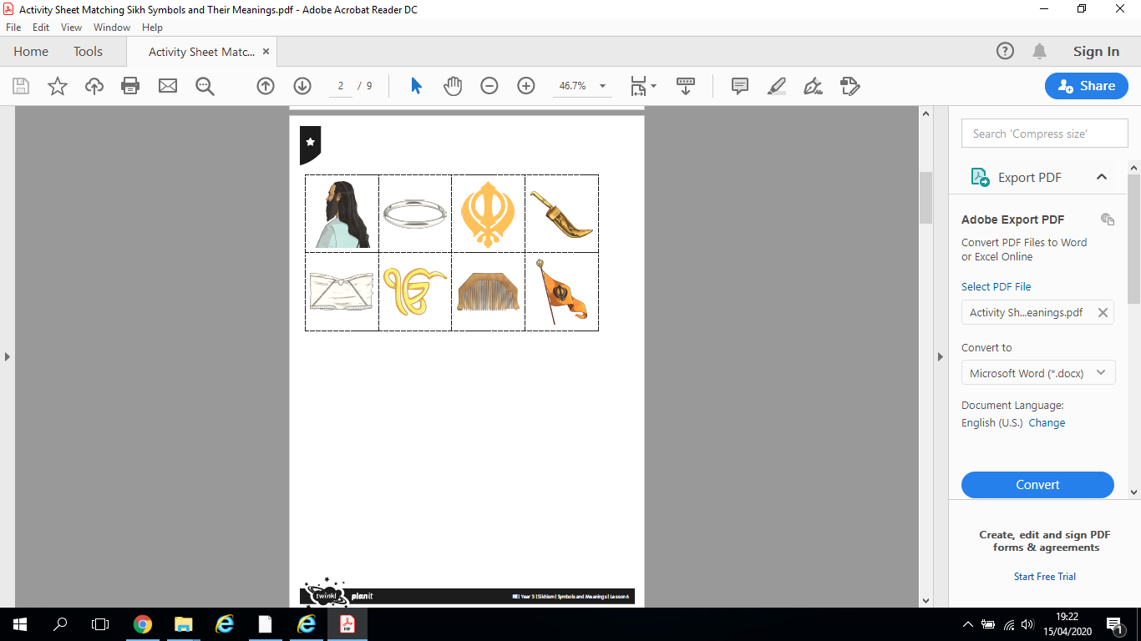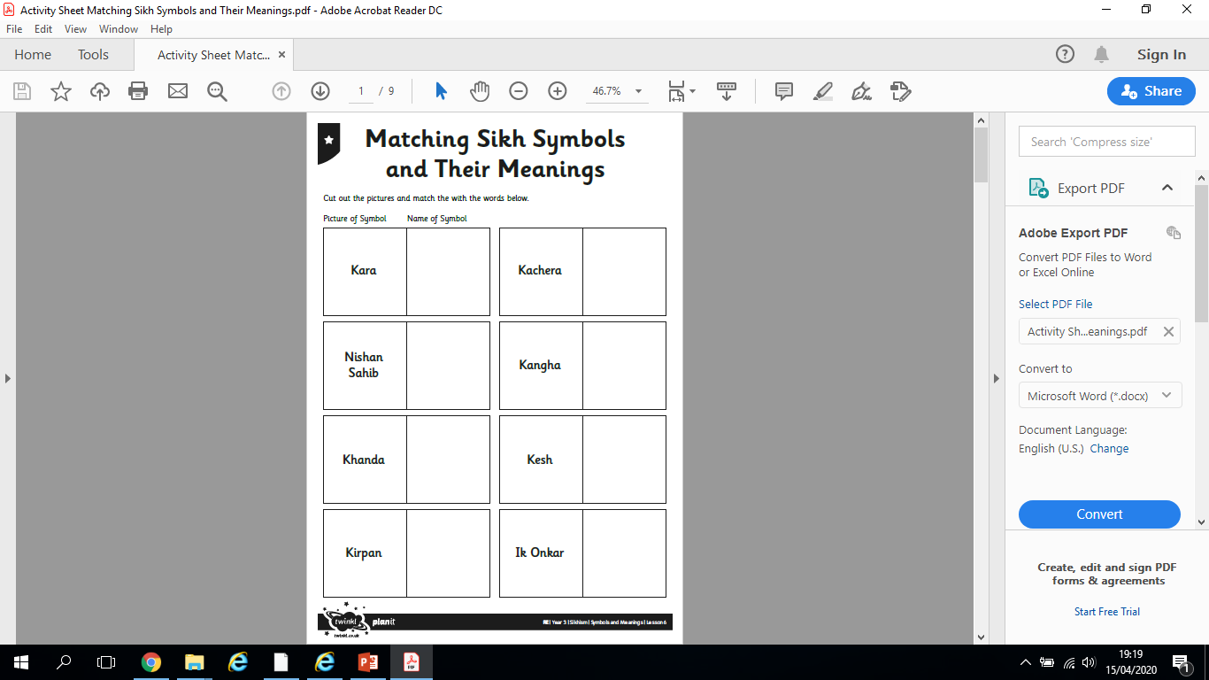

***Children in years 3-6***

Once you have matched the symbols, can you write about each and discuss why it is an important part of the Sikh religion.

Label the picture to explain what happens during Lugar.

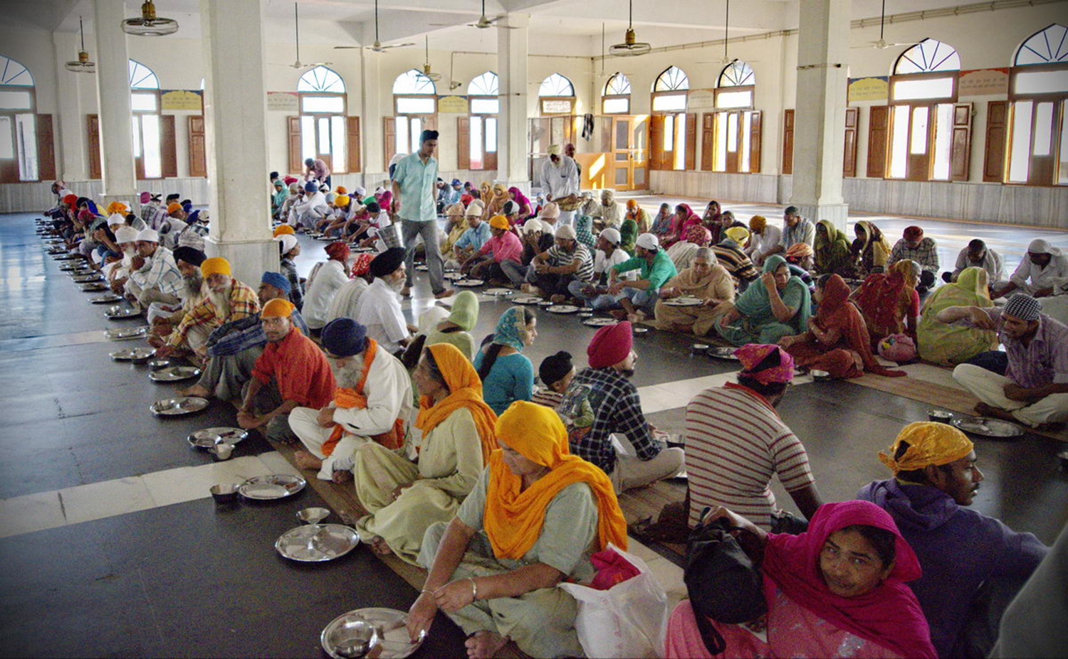

Everyone sits on the floor. This is to show that everyone is equal.