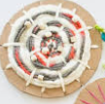
Activity 2 – Woven Art

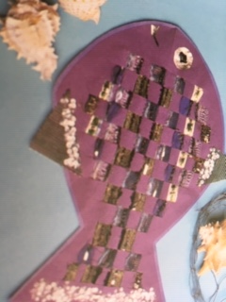
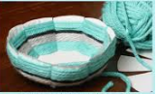
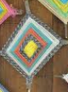
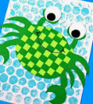
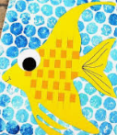

You can make a simple loom to weave on from everyday items like paper plates, a box lid, a circle of cardboard, or lolly sticks.
Here are a few ideas you may wish to choose from:

- Weaving using 2 clean lolly sticks.

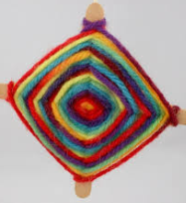
Cross the 2 sticks at right angles.
Using a piece of wool, tie the two sticks in place.
Start at the centre and wrap the wool around one stick before taking it across to the next stick. Wrap the wool around this stick and take it across to the next.
Carry on in the same direction each time.
If you need a new piece of wool, or you want to
change the colour, tie the 2 pieces together at the
back and carry on.
To finish, knot the wool onto another strand at the back of your weaving.

(Continued below)

- Weaving strips of paper to create pictures.

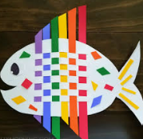
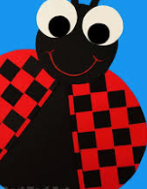
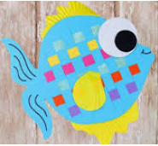

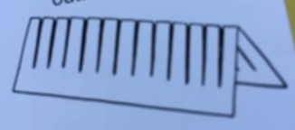

To make a paper loom, fold a piece of paper horizontally, then cut down towards the edge. Open it out again and you can begin weaving.
You can cut a piece of paper to the shape you want before cutting it.
The ladybird is made by weaving a circular shape then cutting it in half. Remember to glue the ends of each strip of paper to keep the weaving in place!

- Using onion or fruit bag mesh to create insects.
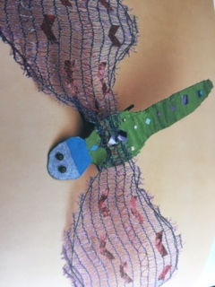

Use a piece of cardboard for the main insect body. Paint and decorate this.
Fold the mesh in half and cut out symmetrical wings.
Weave ribbon, wool or a pipe cleaner around the edge of the wings.
Decorate the wings by weaving items into them
Fix the wings to the body of the insect.

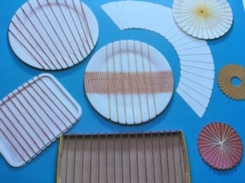
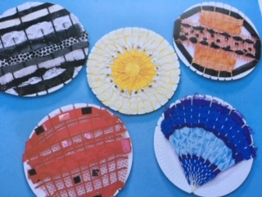
- Use paper plates or cardboard to create a loom

Cut notches in paper plates, cardboard box lids or shaped pieces of card. Use wool or string from a notch at the top to the bottom to create the loom. Fasten the ends securely using sticky tape. Now you can weave strips of material, wool or ribbon to create your design.

For a circular design, cut notches around a circle of card and make a small hole in the centre. Tape a piece of wool at the back of the hole in the middle, then pass it through the centre to an outside notch, then over the back of the circle to the middle again. When there is a strand of wool from the circle to each notch, secure the wool at the back before you begin weaving.

- Create a woven bowl
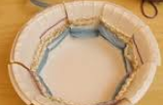

Cut from the top of the bowl down to the flat base at regular intervals. Secure the end of a piece of wool at the base of the bowl with sticky tape. You can then start weaving the wool inside one notch and outside the next. Carry on going in and out of the sections and knot the end piece of wool at the back of the bowl. You can add other colours and piece wool together by knotting pieces together. Try to position the knot on the outside of the bowl.

