Home Learning – Maths
Daily Activities
Timestables:
Children should practise their times tables daily. I have attached (at the end of the document) 2 different worksheets so that you can practise these.
If you would like to do more sheets, using the following link you can create a ‘times tables’ practice sheet.

http://www.timestables.me.uk/printable-pdf-quiz-generator.htm

Children may be at a point where they feel comfortable with all times tables (including the ‘divide by’ questions).
Now, I ask that you choose times tables for your children to practise, covering any weaker areas. The worksheets at the end of the document cover all of the year 3 times tables (2, 5, 10, 3, 4 and 8 times tables).
You may choose to focus on just one or two of these depending on the child.
In class, we use sheets that are 40 questions long. You may want to print these out. Alternatively, you could write up questions or work through them verbally.

Number bonds Focus:
Each week we will focus on number bonds to a different number. This week is 100.
I have attached (at the end of the document) 2 different worksheets so that you can practise these.
NEW GUIDANCE!
In order to improve efficiency, children should begin firstly by counting up in ones to the nearest ten, and then in tens up to 100. It is perfectly normal for children to be counting on their fingers to help them remember how many ones and/or tens they have counted.
If you would like to do more sheets, using the following link you can create a ‘number bonds’ practice sheet like the ones we have been using to practise our times tables.

http://www.mental-arithmetic.co.uk/number-bonds-pdf-quiz-generator.htm

You will need to set the number bonds total to 100 and number of questions to 40. I would imagine that children should be able to finish this sheet in 4 minutes. Try this every day if you can and watch your speed improve! You may want to print these out. Alternatively, you could write up questions or work through them verbally.

Monday:
Activity: Addition and Subtraction Problems
Work through the following questions, showing any working out.
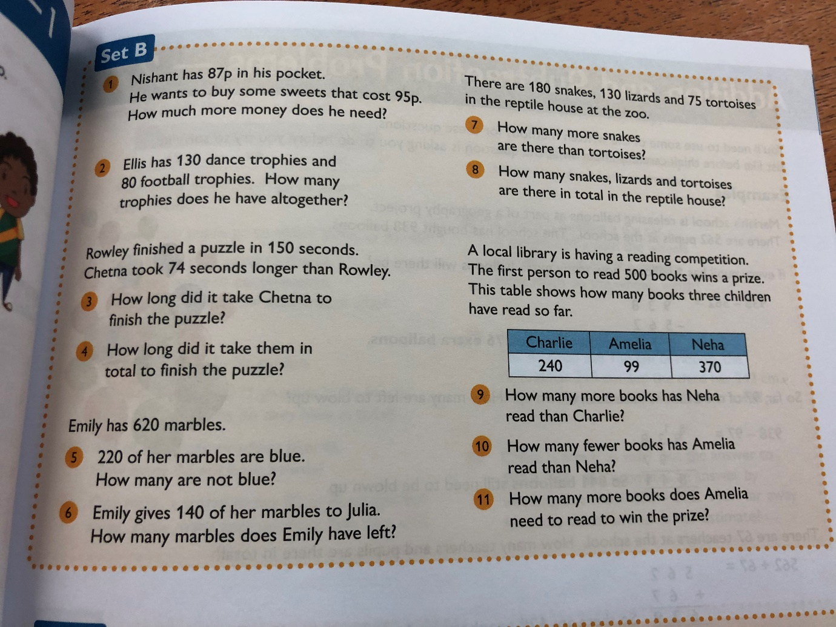

Tuesday:
Activity: Addition and Subtraction Problems
Work through the following questions, showing any working out.

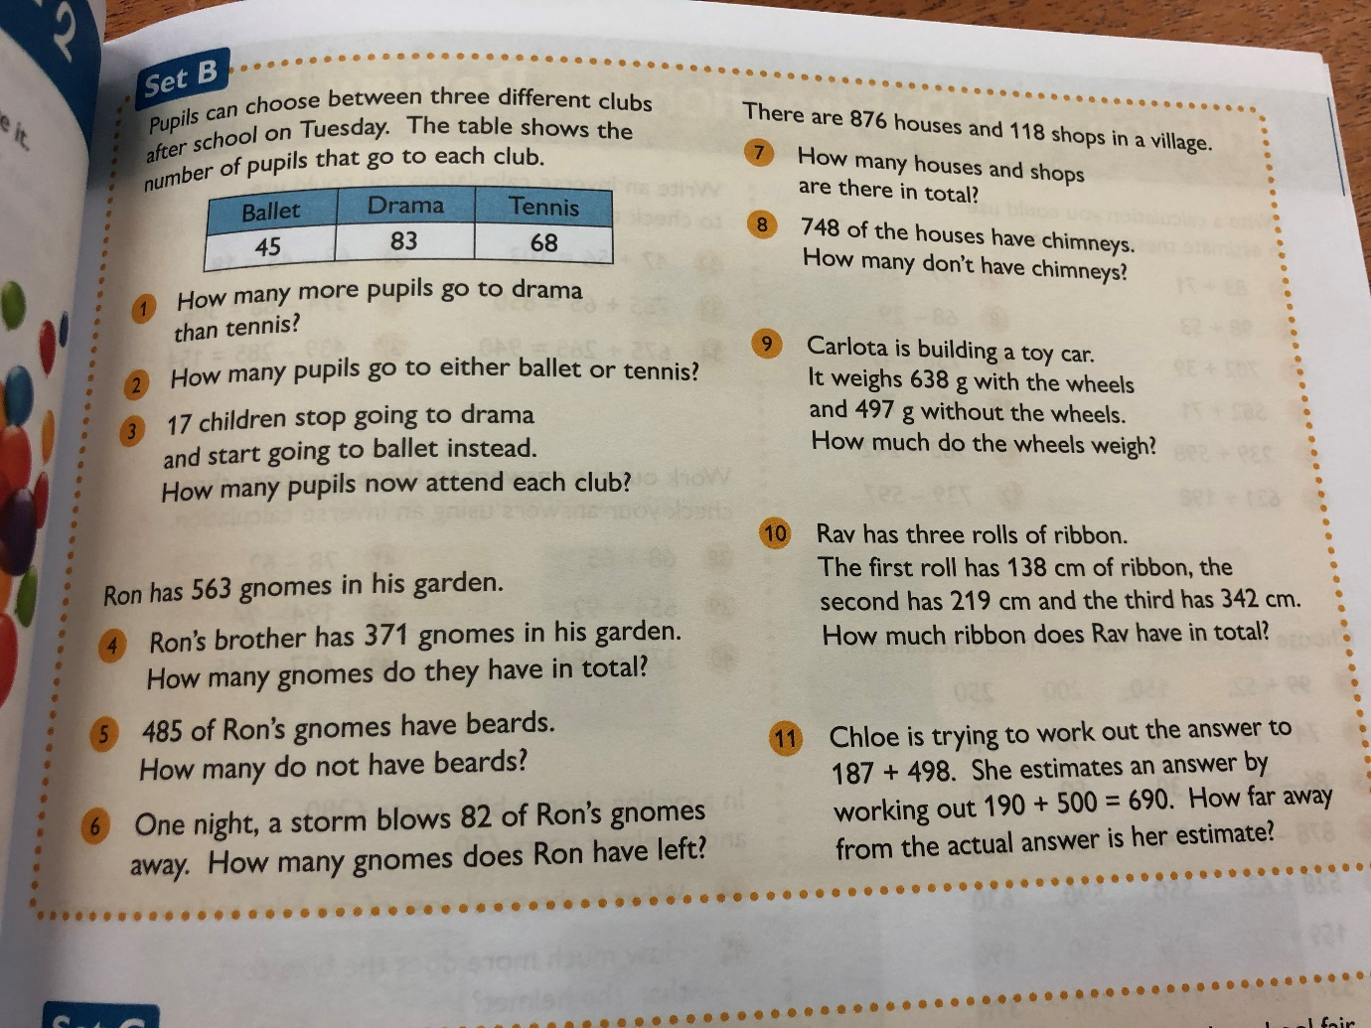

Wednesday:
Activity: Multiplication and Division Problems
Work through the following questions, showing any working out.

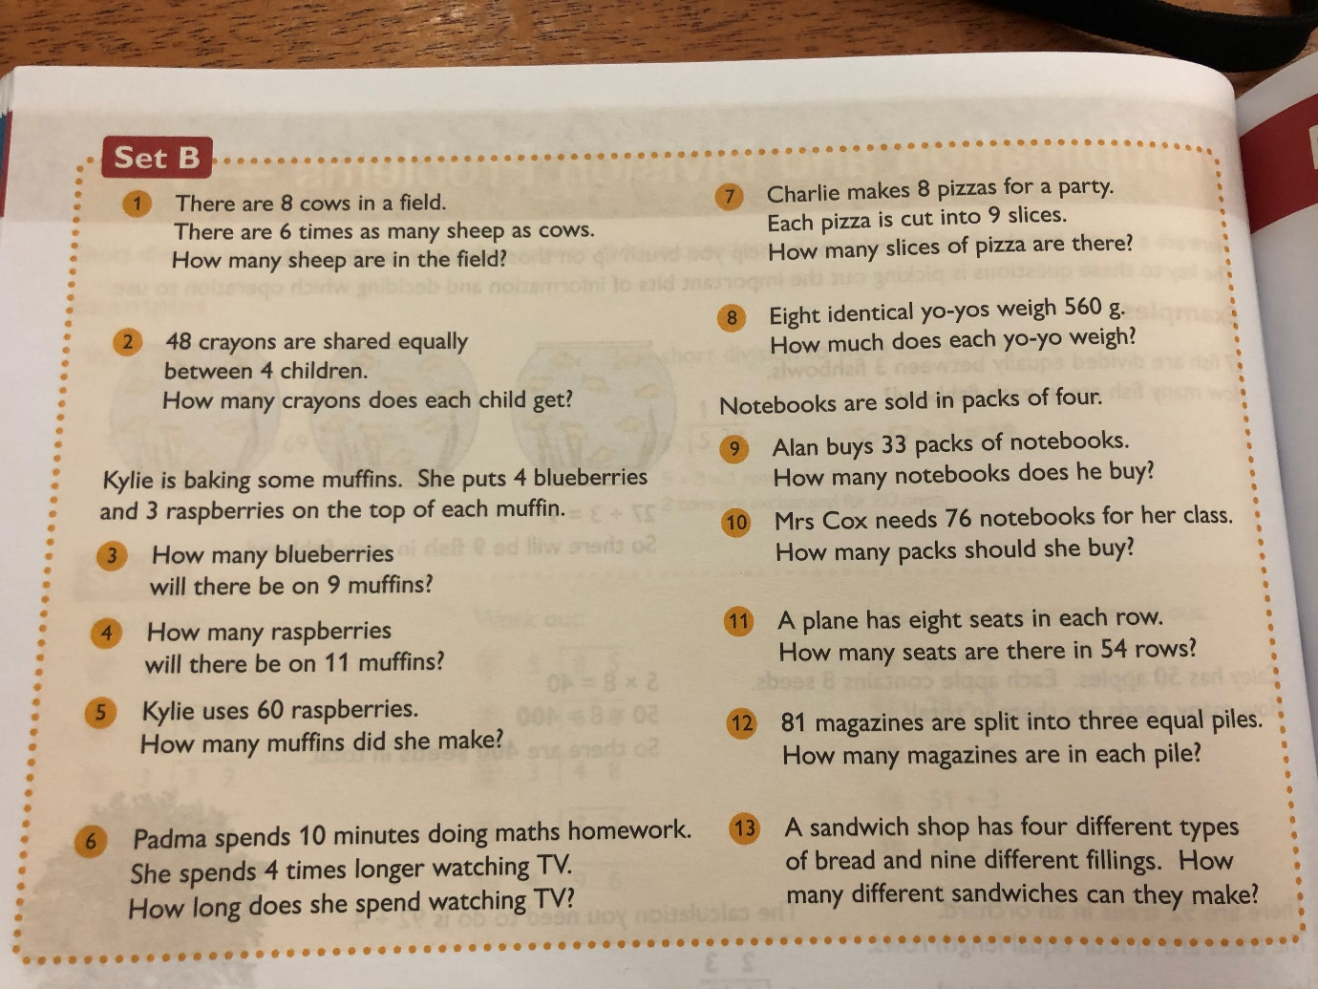

Thursday:
Activity: Multiplication and Division Problems
Work through the following questions, showing any working out.

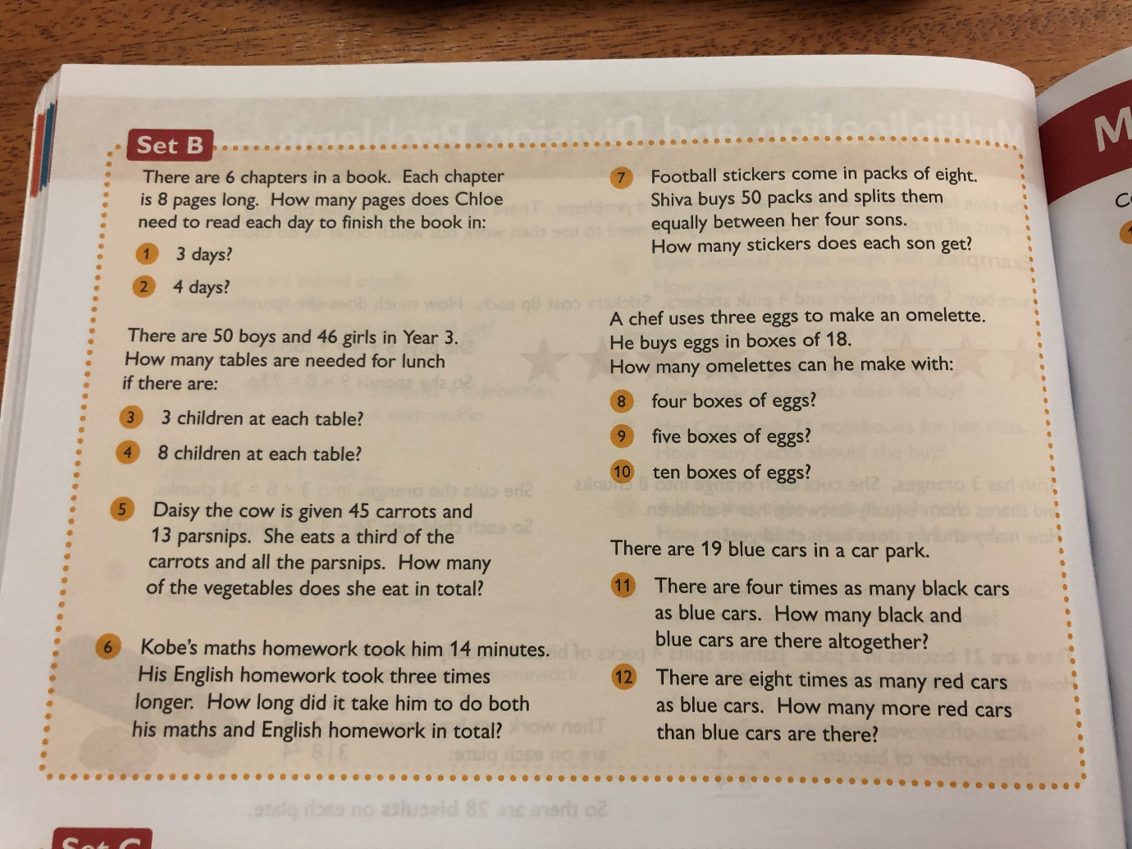

Friday
Spend some time playing these Maths games
Bonds to 20:
This is a simple game, my score on my first try was 1380. Can you beat it?
https://www.mathplayground.com/number_bonds_20.html
This is a great one! I made it all the way to level 7! Give it a try!
https://www.studyzone.tv/game32-codeb185a011318c3d8c938f8d21f4a19d9b
Hit the Button:
This website has 4 different games you could play to practise your number bonds, times tables and division facts.
https://www.topmarks.co.uk/maths-games/hit-the-button
Coin Cruncher:
https://natwest.mymoneysense.com/students/students-5-8/coin-cruncher/
Use the ‘Make the Total’ option first, select pounds and then begin with the ‘hard’ option. Most of you will manage this! If it is a little tricky, go back and do the easier option.
Stone Age Stu:
https://mathsframe.co.uk/en/resources/resource/544/Stone-Age-Stu-Times-Tables
You can choose your own levels. Pick the times tables you want to practise!
Calendar:
https://mathsframe.co.uk/en/resources/resource/261/using-a-calendar
This one gives you some practice on the months of the years and dates. Similar to what we do in Maths Meetings.
Telling the Time:
https://mathsframe.co.uk/en/resources/resource/116/telling_the_time#
You can set your own difficulty here! You should look at either the ‘read time to the quarter hour’, ‘read time to the nearest 5 minutes’ and ‘read time to the nearest minute’. You can choose which difficulty, depending on how confident you feel, but do try and challenge yourselves too!
Arithmetic Archery:
https://mathsframe.co.uk/en/resources/resource/399/Archery-Arithmetic-Multiplication
You can use this to practise any times tables I set. (Or challenge yourself and begin to practice next years. Only do this if you are very confident with all of your year 3 times tables.)
Times Tables practice 1.
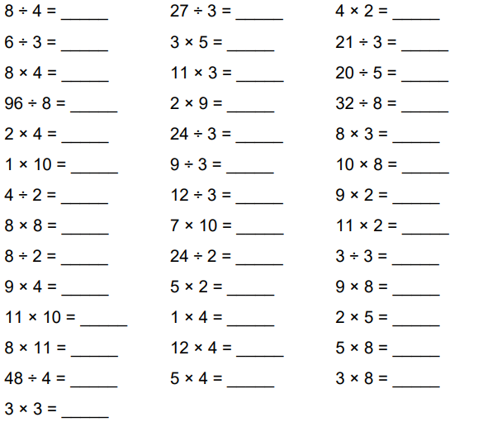

Times Tables Practice 2.
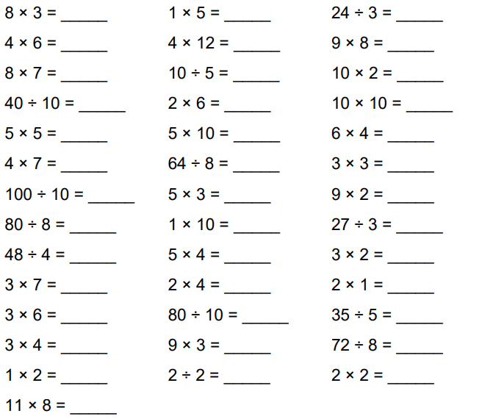

Number Bonds Practice 1.
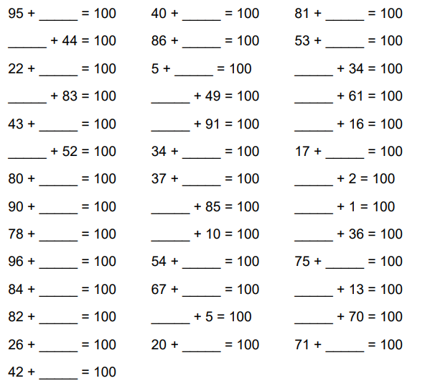

Number bonds Practice 2.
