Wednesday Activity: Round to 10, 100, 1000

- Draw and complete:

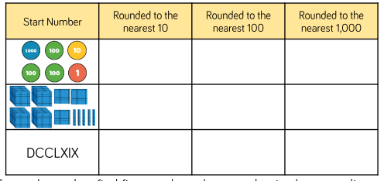

- Write the list of different numbers for each number:

- Create the table and complete:
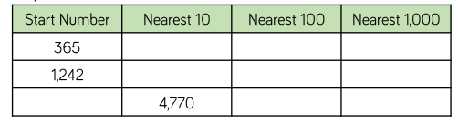

- What could Jack’s number be? Can you find all the possibilities?
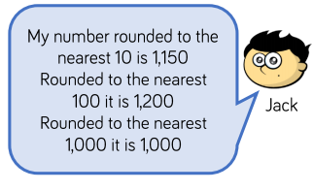
- Do you agree with Whitney? Explain why.
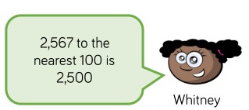

- Explain the mistake Teddy has made:

