Monday Activity: Numbers to 100,000

When answering the questions, please use key maths vocabulary:
place value | column | addition | subtraction
tens | hundreds | thousands | ten thousands
hundred thousand | part-whole model | represents | number line

- Draw and match the following:
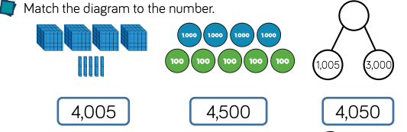

- Which of the four diagrams, below, is the odd one out?
Explain how you know.

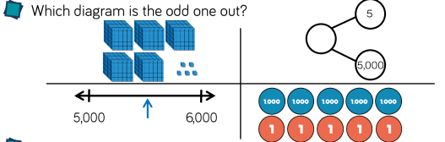
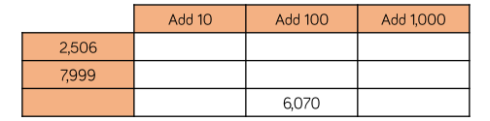
- Create the table and complete:

- Take your time and persevere in working this out:
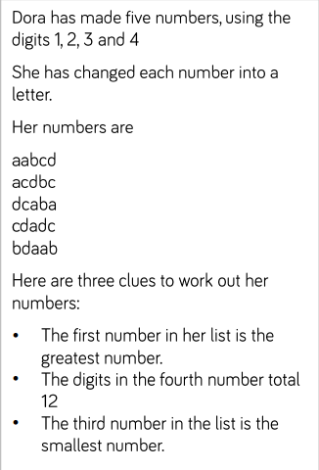

- Read the question. Is Tommy correct? Explain your answer.
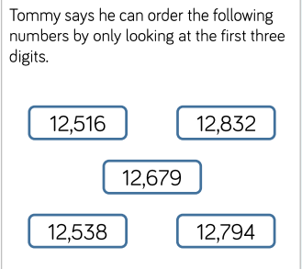

- Copy and answer the following questions:
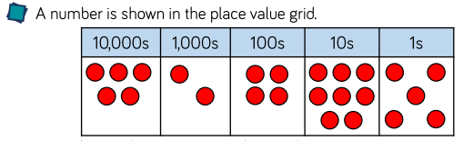
- Write the number represented above, in digits and then in words.
Four friends add counters to the above place value grid. Write each new number they create, both in digits and then in words.
- Ava adds ten to the above number.
- Amelia adds one hundred to the above number.
- Kieran adds one thousand to the above number.

- Complete the grid below to show the same number in different ways.
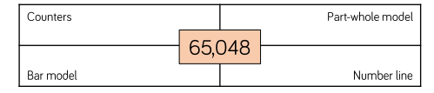
Remember with bar models you partition the whole within the bar or rectangle. For example, to represent 122, you can partition and create the bar model as follows:
100 10 10 1 1

122
8) Copy and complete the missing numbers:
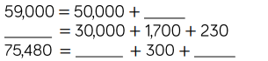

- Copy the number line and answer the following questions:

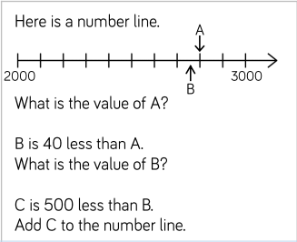

- Rosie counts backwards and forwards from 317 in 10s.
Looking at the following numbers below, what numbers will
NOT count to? Explain why Rosie will not count to the other
numbers? Explain
