Art and Design Activities Term 6
This term, whether you are completing art activities in school or at home, we will all be working towards putting a display of artwork on the display boards in the hall. Each week, you can choose a different style of art. If you are working at home, please keep your artwork somewhere safe so that you can bring it into school on your return. (Please remember to put your name on the back.)
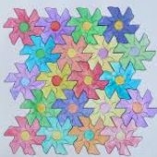
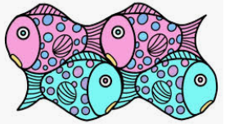
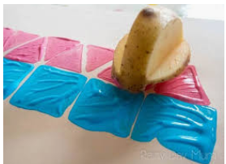
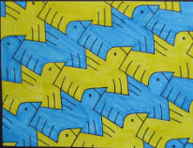
Activity 1 - Tessellation Art
Tessellation art is when a surface is covered with one or more shapes, creating a design with no overlapping shapes and no gaps.
You can make a simple design, just by cutting out a cardboard triangle and drawing around it to create patterns.

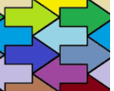
You could use an arrow shape (insert an arrow shape on a word document, then copy and paste it in different positions as your starting point).

Make sure this measurement is half the length of the arrow base.

You could be adventurous and make your own, unique shape to tessellate like this:
Step 1
Use a square piece of card. Draw a line on the left side.

Step 2
Cut this piece out and move it to the right hand
side of the card. Keep it the same way up, then
sellotape it on. This shape will now tessellate.
Draw around it to fill a whole page before colouring
in your design.

Step 3
If you wish, do the same with a line drawn at the bottom
of the shape. Cut it out and sellotape it to the top.
You can make some great tessellation monsters
this way.

Step 4
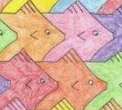
Draw around the shape to cover a page.
Colour in your design.

Step 5
Have fun experimenting with different designs. You can use potato print shapes, computer-generated shapes, or your own, designed shape. Enjoy!

