Art and Design Activity 3
Please remember to keep any artwork safe so that it can be displayed, in the future, on the hall display boards.
Aborigine-Style Art
Australian Aboriginal tradition refers to Dreamtime when ancestral beings (people, animals, birds, plants, rain, clouds and stars) moved on the Earth. According to Aboriginal tradition, the ancestors gave the people laws on how to live together and how to live on the land without harming it. Knowledge about Dreamtime is depicted in traditional Aborigine artwork, where symbols used have specific meanings. These are some of them:

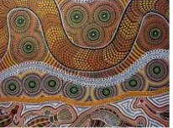
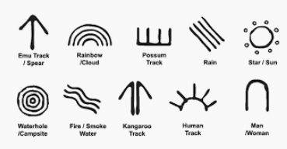

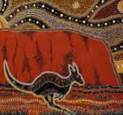

- A boomerang design
- Cut out a boomerang shape from card.
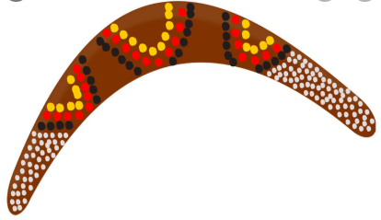
- Paint the background colour. Let this dry.
- Add the patterns using paint or strips of coloured paper or washi tape. Add dots using cotton buds and further, fine detail with a black felt-tip pen.
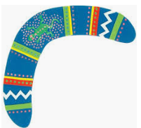

- Hand print

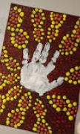
- Paint a dot-filled background, using finger painting or painting with cotton buds. Let the background dry.
- Then, add your handprint in a contrasting colour.
- You could decorate the handprint with further coloured dots or leave
it plain.

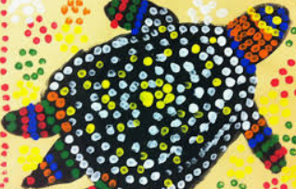

- Try using cotton buds to create a painting of an animal.
- Paint the background colour you would like.
- Paint on the shape of the animal.
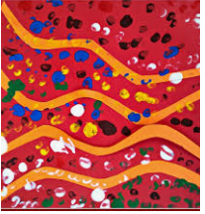
- Decorate the animal shape with coloured dots, using a cotton bud.

- You could create an abstract painting
Use finger painting for the dots.

