Peer Gynt: In the Hall of the Mountain King
Edvard Grieg

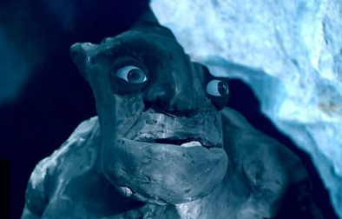

Music Project Pack

Introduction
Grieg's 'Peer Gynt Suite' tells the story of a young boy – Peer Gynt, who falls in love with a girl but is not allowed to marry her. He runs away into the mountains but is captured by trolls who take him to their King. Peer Gynt tries to escape but is chased by the trolls and runs into the troll King.
Watch the first video on the webpage, for an introduction to the piece and to hear it played by an orchestra.
https://www.bbc.co.uk/teach/ten-pieces/KS2-edvard-grieg-in-the-hall-of-the-mountain-king-from-peer-gynt/z7nf3k7
Now look at the activities below. You will find further instructions for each activity on the following pages and you can choose which ones you would like to do. There are lots of different types of activity, there should be something for everyone! You will notice, you can tick one of them off already!

Introduce it   | Draw it   | Perform it  
Characterise it   | Research it | Place it  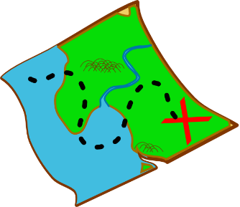
Story-Tell it   | Compare it   | Play it  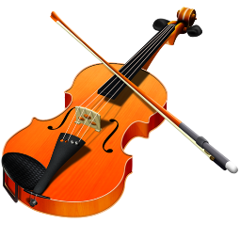

Remember, any work you do at home can be sent in for us to put onto our home learning gallery!
Introduce it: | Read the introduction above and listen to the piece of music and think about the following questions.  What are your first impressions about it? Did you enjoy it? What did you like about it? Was there anything you didn’t like?  You don’t need to write anything down unless you want to. You can just think about it or discuss with someone in your family if they are free.
Draw it: | Listen to the piece of Music, As you listen, you could draw:  - The hall of the Mountain King – his grand, underground palace.  - The Mountain King himself – a terrifying troll.  - Peer Gynt running away down a twisty path.  - OR you could draw all three pictures to create a storyboard for the piece of music.  You could create these pictures using paint, cutting and sticking or even by creating pictures on a tablet app or computer programme. Remember, you could always just use a pencil and paper. Sometimes, these pictures can be the most effective!
Perform it: | Imagine you are Peer Gynt escaping from the hall of the Mountain King.  Play the piece of music and recreate your own escape from the Mountain.  Think about how Peer Gynt might move as he tries to creep away. How does the music change towards the end? How could you show this in your movements?  You could record your performance, practise and do a show for your parents, or just do it for fun on your own! Remember to be safe and sensible while you practise!
Characterise it: | There are two other character’s we must meet! Ase is Peer Gynt’s mother, and Aritna is his girlfriend.  On a piece of paper, draw two ovals.  Listen to the first piece:  https://www.youtube.com/watch?v=gcEnSITNaGM  This piece is about Anitra (his girlfriend). Using the oval, can you draw her face? How old is she? What might she look like?  Now listen to this piece:  https://www.youtube.com/watch?v=VrpM-lGnoyA  This piece is about Ase (his Mother). Using the other oval, can you draw her face? How old is she? What might she look like?  Now, around or beneath the picture, can you write some words that tell me how they might be feeling? Think about the music and how the music sounds. Write me a sentence or two to explain why they might be feeling that way.
Research it: | Use the following links to do some research of your own into the life and music of Edvard Grieg.  You could create a poster, a powerpoint presentation or a non-fiction text to show me what you find out.  You might like to include:  - Where was Grieg from?  - What type of music did he write?  - When was Peer Gynt written?  - A brief summary of the story of Peer Gynt.  - Information about some of his other pieces.  https://www.bbc.co.uk/teach/ten-pieces/KS2-edvard-grieg-in-the-hall-of-the-mountain-king-from-peer-gynt/z7nf3k7  https://www.classicsforkids.com/composers/composer_profile.php?id=32  https://victoriaboler.com/blog/2016/5/2/introducing-edvard-grieg-classical-music-for-young-musicians  https://www.classicfm.com/composers/grieg/guides/grieg-facts/leipzig-conservatory-3/
Place it: | Listen to this piece from the Peer Gynt suite. It is used as a ‘setting’ for the story.  https://www.youtube.com/watch?v=S0cZT34Y-cs  Think about what setting this could represent? What time of day is it? What might I see if I was there? What is the weather like? Who/what is around me?  You could show me by writing a setting description or by creating a piece of artwork. Think about the mood of the piece of music and how you can show that in your writing/artwork.
Story-Tell it:   | The introduction to the piece has a brief summary of the story. Can you now write the full story?  We know 4 characters, Peer Gynt, Ase (his mother), Aritna (his girlfriend) and the Mountain King. We also know one setting, the underground hall of the Mountain King.  There are a few things we don’t know. How does the story start? Where is it set? Why can Peer Gynt not marry Aritna? Does he escape the mountain? How does the story end?  You will need to think about these things before you write the story. Can you fill in the gaps in the story so that we have all of the details?
Compare it: | Here is the piece of music you have been listening to:  https://www.bbc.co.uk/teach/ten-pieces/KS2-edvard-grieg-in-the-hall-of-the-mountain-king-from-peer-gynt/z7nf3k7  Here are 3 different versions of the same piece of music:  Organ - https://www.youtube.com/watch?v=dBoGdJ54oWI  Tesla - https://www.youtube.com/watch?v=8LAhKkPUo_A  Guitar - https://www.youtube.com/watch?v=Ld3sSag3NaQ  I would like you to compare the different versions of this piece. What is the same and what is different.  You could do this using full sentences, or you could create a table with 4 columns (one for each piece).  What instruments are being played? How do they sound different? How do the instruments make their sound? How any people are playing?  Finally, tell me which version is your favourite and explain why.
Play it: | Instrumentalists: At the bottom of the web-page there is sheet music, for beginners up to grade 5, for you to be able to play along with the piece!  Non-instrumentalists: You can still play along! What could you use in your house to create the crashings and the rumblings that we hear towards the end of the piece?  Record yourselves playing along to the original track! Can you keep in time? Can your rumbles and crashes all happen together? Can you convince your family to create your own orchestra?

