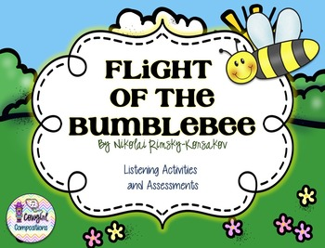

KS1 Music Project Pack

Introduction
Watch the video below. It is a short animated clip, with the music playing alongside it. You may want to discuss the bold writing below which will serve as a short introduction to the piece.
https://www.youtube.com/watch?v=X14kC-sEH0I
“Nikolai Rimsky-Korsakov was very good at using the instruments of the orchestra to create pictures and stories. In “Flight of the Bumblebee” he used the string family to create a musical “bumblebee.” But, this is no ordinary insect—this bee is really a prince! The music comes from Rimsky-Korsakov’s opera The Tale of Tsar Saltan. In the story, a magic swan turns the prince into a bumblebee so that he can visit Tsar Saltan without being seen. As you listen to the music, can you imagine a bumblebee buzzing around the Tsar and then quickly flying away so it doesn’t get caught?”
Here are some activities you might like to do, inspired by the Lark Ascending. You will find further instructions on the following pages.
Question it   | Draw it   | Move it  
Story-Tell it   | Capture it   | Imagine it  

Remember, any work you do at home can be sent in for us to put onto our home learning gallery!

Question it | Discuss these questions with your child. They might give answers that seemingly make no sense, but this is the beginning of them making sense of music and interpreting sound. There are no ‘correct’ answers, but some answers may make more sense than others.  What do you think the bee is doing?  How do you think the bee is feeling? Why?  How does the piece of music make you feel?  What time of day do you think it was?
Move it | Use the music from the video clip. Ask your child to imagine they are the bee and move around as if they are the creature. This could be done indoors or outdoors.  Play a game of musical statues. Every time you stop the music, they should freeze in their best ‘insect’ poses.
Story-Tell it | Create a story that uses a busy bumblebee as the main character! You could write sentences, or draw a series of pictures like a comic strip. Where could the bee be buzzing too? Why is he in such a rush? Does he meet any other unusual characters?
Draw it   | Encourage your child to draw, colour in, paint, decorate or make their own bee (or other insect).  They could then ‘fly’ the bee along to the piece of music.
imagine it: | Play the piece of music again. Ask the children where they think the lark might fly to. Get them to describe the setting, thinking about what the bird might see and hear as it flies.  You could do this as a discussion, write some simple sentences or draw a picture of what the bird can see.
Capture it: | Head outdoors. See if you can capture a bee on camera. You will have to be quick as they are very busy! Remember to do this safely, and don’t get too close. Bees can sting. They are attracted to flowers, so this might be a good place to start looking!

