Circle the set that has the most money
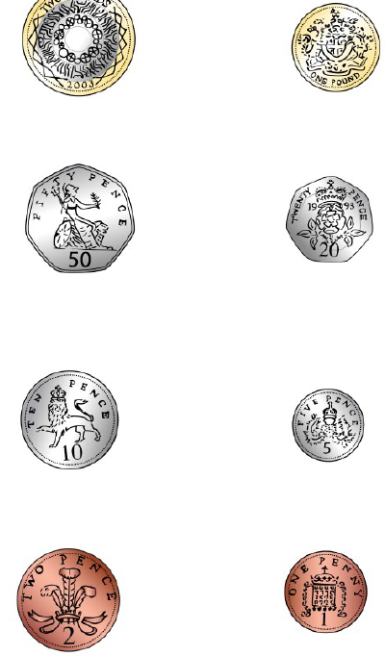
Monday

Circle the set that has the least money

Tuesday

 | 9p | 9p | 7p | 12p
9p |  |  |  | 
6p |  |  | 
14p
8p

Wednesday

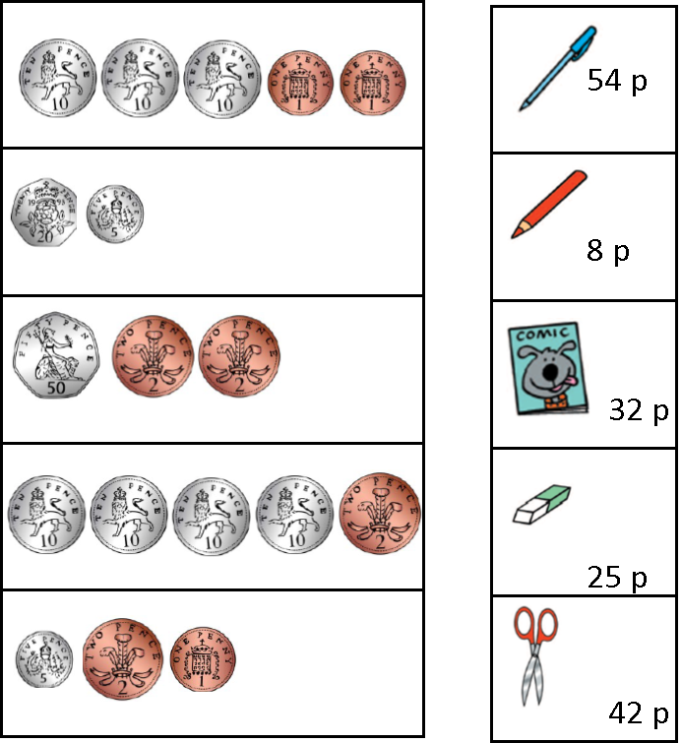

Thursday

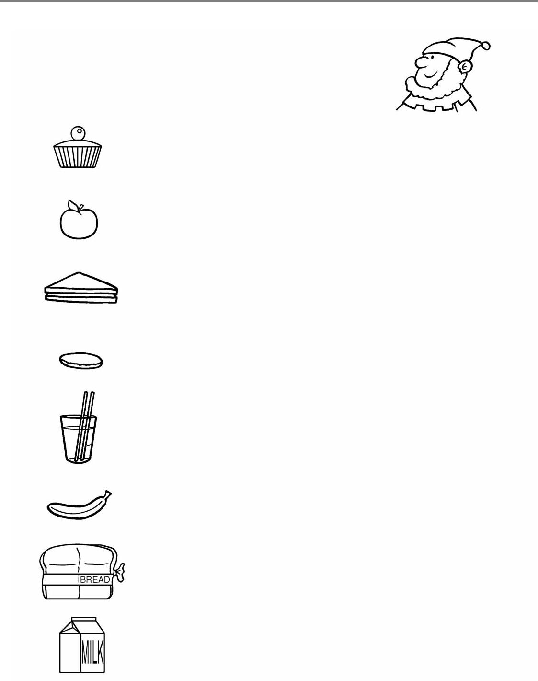


Cake................................. 40 p
Apple............................... 20 p p
Sandwich........................... 50 p
Chocolate biscuit................. 10 p
Orange juice....................... 30 p
Banana............................ 30 p
Milk............................... 40 p
Fairyland Menu

p

p

p

Thursday



