Reading comprehension WHO? WHERE? WHEN? WHAT? WHY?
For the fiction pieces, you may have slightly different answers – as long as they are based on the text.

From Newsround 28 April 2020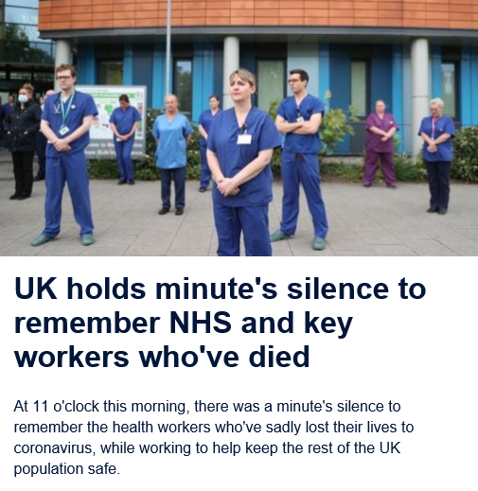
Who?
Where?
When?
What?
Why?


- From Newsround 28 April 2020 (some answers are implied)

Plans to restart the Premier League season will step up this week with clubs meeting on Friday to talk about possible options.

Who?
Where?
When?
What?
Why?

- From “A Place Called Perfect”

Sometimes Violet liked silence, but not now; Blindness made silence scary. She pushed her hands under her thighs and swung her legs, trying to remember a happy song.
Suddenly she heard faint footsteps enter the shop at speed, growing louder as they paced towards her. She looked blindly in the direction of the sound.

Who?
Where?
When?
What?
Why?

- From “The New House”

Murph hated the new house more than he could remember hating anything, ever. A light wind, such as you often find at the beginning of a story, tousled his shaggy brown hair as he stood looking up at it. He was trying to work out, with all the power of his just eleven-year-old brain, why it made him feel so rotten.

Who?
Where?
When?
What?
Why?

- And finally ...
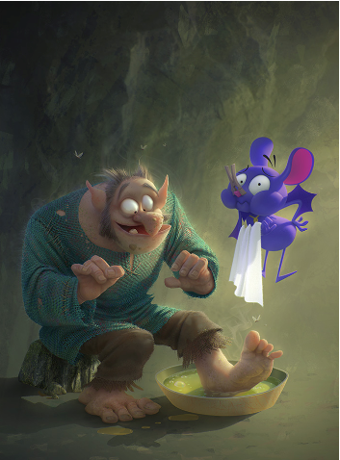
Who?
Where?
When?
What?
Why?

Answers (some of which are suggestions) on the next page

1.
Who? - health workers
Where? - UK
When? – today (28 April) at 11 o’clock
What? – a minute’s silence
Why? – because health workers who had lost their life (to keep the UK population safe)

2.
Who? – Premier League
Where? - (UK because the Premier League is in the UK – but that is implied)
When? – Friday this week
What? – talk about possible options
Why? – to restart the Premier League

3.
Who? - Violet
Where? – in a shop
When? – not given
What? – she is scared
Why? – she is blind

4.
Who? – Murph (and eleven-year-old boy)
Where? – not given, but somewhere outside because there is wind and he is looking at the house
When? – not given
What? – he hates the house
Why? – probably because he just moved there (it says it is the new house)

5.
Who? – a giant/troll/ogre (and his servant?)
Where? – in a cave
When? – morning or late afternoon/evening (because there are long shadows)
What? – he has his feet washed
Why? – they are smelly (the blue creature has a peg in its nose)

