The Lark Ascending
Ralph Vaughan Williams

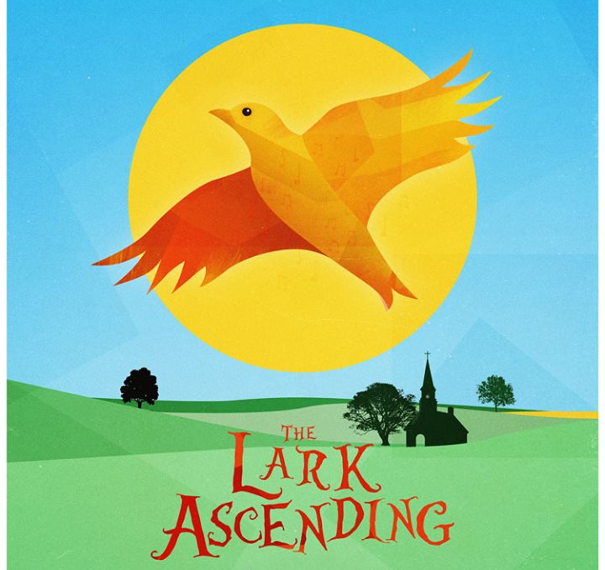

KS1 Music Project Pack

Introduction
Watch the introduction video with Molly Rainford. You may want to discuss what a lark is. You don’t need to watch the whole video. Up to 3 minutes will be enough for younger listeners.
https://www.bbc.co.uk/teach/ten-pieces/primary-classical-music-ks2-vaughan-williams-lark-ascending/zb2jrj6
Here are some activities you might like to do, inspired by the Lark Ascending. You will find further instructions on the following pages.
Question it   | Draw it   | Move it  
Explore it   | Compare it | Imagine it  

Remember, any work you do at home can be sent in for us to put onto our home learning gallery!

Question it | Discuss these questions with your child. They might give answers that seemingly make no sense, but this is the beginning of them making sense of music and interpreting sound. There are no ‘correct’ answers, but some answers may make more sense than others.  What could the lark be doing?  Do you think the lark is happy or sad?  Is the lark flying high in the sky or low to the ground?  Can you imagine any other animals in this piece?  How does the piece of music make you feel?  What time of day do you think it was?
Move it | Use the music from the video clip. Ask your child to imagine they are the lark and move around as if they are the creature. This could be done indoors or outdoors.  Play a game of musical statues. Every time you stop the music, they should freeze in their best ‘birdie’ poses.
Explore it | Go to an outside space with your children; the garden, the park or the beach!  Ask the children to listen really, really carefully. What can they hear? How many noises can you hear that are made by the natural world? How many noises can you hear that are made by man-made objects?  How many of these sounds can you make using your voices and bodies?  You could record all of these sounds on your smart phone!
Draw it   | Encourage your child to draw, colour in, paint, decorate or make their own bird.  They could then ‘fly’ the bird along to the piece of music.
imagine it: | Play the piece of music again. Ask the children where they think the lark might fly to. Get them to describe the setting, thinking about what the bird might see and hear as it flies.  You could do this as a discussion, write some simple sentences or draw a picture of what the bird can see.
Compare it: | Listen to these other pieces inspired by animals. How do they sound different?  How do they make you want to move? You could play musical statues with these pieces too!

