A Night on Bare Mountain
Modest Mussorgsky

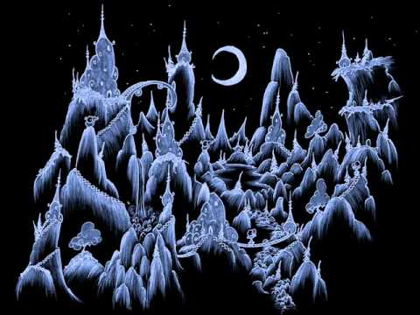

Music Project Pack

Introduction
A Night on the Bare Mountain describes a short story in which St John sees a witches' Sabbath on the Bald Mountain near Kiev in the Old Russian Empire. It's a wild and terrifying party with lots of dancing but when the church bell chimes 6am and the sun comes up the witches vanish.
Watch the first video on the web page for a short introduction, but beware, it gets quite loud and there might be some bits that make you jump!
https://www.bbc.co.uk/teach/ten-pieces/primary-music-ks2-mussorgsky-night-on-bare-mountain/zvw2t39
Now look at the activities below. You will find further instructions for each activity on the following pages and you can choose which ones you would like to do. There are lots of different types of activity, there should be something for everyone! You will notice, you can tick one of them off already!
Introduce it   | Imagine it   | Role-play it  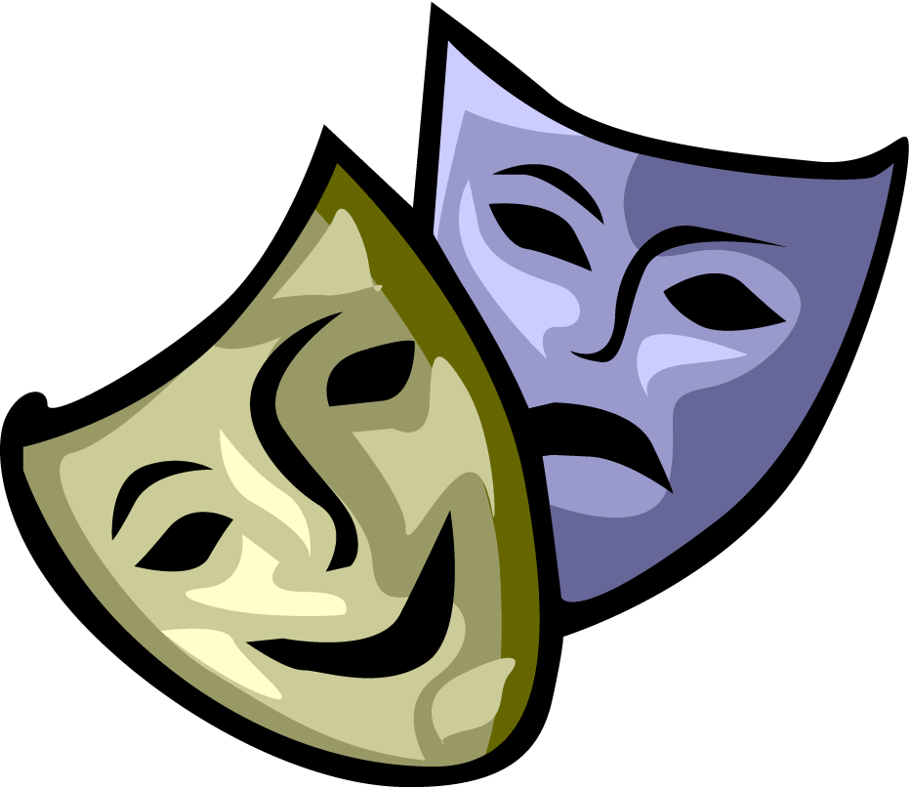
Speak it   | Research it | Paint it  
Story-Tell it   | Compare it   | Read it  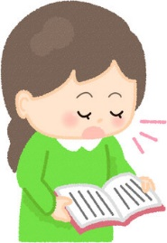

Remember, any work you do at home can be sent in for us to put onto our home learning gallery!
Introduce it: | Read the introduction above and listen to the piece of music and think about the following questions.  What are your first impressions about it? Did you enjoy it? What did you like about it? Was there anything you didn’t like?  You don’t need to write anything down unless you want to. You can just think about it or discuss with someone in your family if they are free.
Imagine it: | Think about the party the witches are having on the mountain. Imagine you are one of them. How might they decorate the party space? What might they be eating? How are they dancing? What else are they getting up to?  You could show me by writing a setting description or by creating a piece of artwork. Put on your witches thinking hat and have fun! What is the wildest, wickedest, witchiest thing you can come up with?
Role-play it: | Imagine you are a news reporter or a talk show host. What questions would you ask the witch?  Write down 5-10 questions that you think your audience will want to know the answers to.  Here are a couple of examples:  - Why is this one night of the year so special?  - Why must you disappear at 6am?  When you have come up with a few questions, you could pair up with an adult, brother or sister at home. You could interview them and see what they could come up with, or they could interview you and you can use your imagination to answer the questions.  Remember, if you are being the witch, you might like to use a witchy voice, or act like a witch!  Record it and it will be like you are in a real television studio!  If you can’t convince someone to record you and be a chat how partner, you could write the answers down instead! That way, you can still use all of creativity to come up with some wicked witch answers!
Speak it:   | Create a mind map with ‘a Night on Bare Mountain’ in the middle.  Play the piece of music and think about the sounds you can hear. What onomatopoeic words could you use? (Remember, onomatopoeia is where a word sounds like the noise it makes, e.g. bang, screech and sizzle).  There are a lot of instruments and a lot of sounds. If we were going to recreate this piece of music using only onomatopoeic words, which ones would we use?  You could always use a thesaurus to come up with synonyms for your onomatopoeic words!  Extra Challenge:  You could record your own spoken composition using only the words from your mind map. If you have any family members that are willing to help, you could get them to read words to and layer up the sounds, just like the instruments of the orchestra!
Research it: | Use the following links to do some research of your own into the life and music of Modest Mussorgsky.  You could create a poster, a PowerPoint presentation or a non-fiction text to show me what you find out.  You might like to include:  - Where was he from/when was he born?  - When did he write ‘a Night on Bare Mountain’?  - What other creatures did he write music about?  - Any other interesting or unusual facts?  https://www.bbc.co.uk/teach/ten-pieces/primary-music-ks2-mussorgsky-night-on-bare-mountain/zvw2t39  https://www.classicsforkids.com/composers/composer_profile.php?id=47  https://makingmusicfun.net/htm/f_mmf_music_library/hey-kids-meet-modest-mussorgsky.php
Paint it   | Watch Ricky Martin create a paint masterpiece:  https://www.bbc.co.uk/programmes/p0282x1z  Use your paint and create an expressive piece of art. Notice he doesn’t draw pictures, but makes marks and uses shapes and lines that he thinks represent the music. Listen to the way he describes what he is doing as he is drawing, it will help you to create your own!  He does an enormous painting, yours don’t need to be that big! You also don’t need to use paints. You could create an amazing piece of artwork using the same techniques with pencils or felt tip pens!
Story-Tell it:   | Tell the story of the witches. Make one witch your main character and think about these things?  - Where has she come from?  - What does she look like?  - Why is she celebrating?  - Where do they go at dawn?  - What might happen if they don’t ‘disappear’ at dawn?
Compare it: | Here is the piece of music you have been listening to:  https://www.bbc.co.uk/teach/ten-pieces/primary-music-ks2-mussorgsky-night-on-bare-mountain/zvw2t39  Now listen to these pieces. Some of them are quite long, you only need to listen to a couple of minutes (Unless you are enjoying it, then you can listen to more!)  Danse Macabre - https://www.youtube.com/watch?v=71fZhMXlGT4  Masked Witches Sabbath - https://www.youtube.com/watch?v=G2aHglwKH_I  Verdi’s Macbeth - https://www.youtube.com/watch?v=SiWhkH_FQWg  Compare the pieces. What do you notice about them? What is the same and what is different? How do the pieces make you feel? What instruments can you hear in each piece?  Finally, tell me which piece is your favourite and explain why.
Read it:  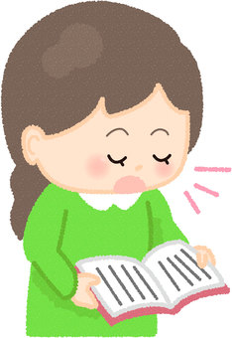 | Here are the words from a famous Shakespeare play: Macbeth.  Can you deliver a dramatic reading of the poem? You could learn all the lines off by heart or you can just read them from the page.  I want to hear your most evil witch voices, clear speech and good use of the punctuation. You are casting a spell and I want to believe you are the most terrible, fearsome witch in all of the land!  You will find the poem on the next page!  Double, double, toil and trouble;  Fire burn, and cauldron bubble.  Fillet of a fenny snake,  In the cauldron boil and bake;  Eye of newt and toe of frog,  Wool of bat and tongue of dog,  Adder’s fork and blind-worm’s sting,  Lizard’s leg and owlet’s wing,  For a charm of powerful trouble,  Like a hell-broth boil and bubble.  Double, double, toil and trouble;  Fire burn, and cauldron bubble.  Extra Challenge:  You could write your own poem, filled with all of the ingredients required to create a magic potion!

