Question 1: Who is Jewish?

Activity: Watch the video clips below. What have you learnt about the Jewish faith?

Resources:
Key facts about Judaism told by children
https://www.chabad.org/kids/article_cdo/aid/1347962/jewish/Why-I-Like-Being-Jewish.htm

My life religion - Charlie talking about his religion
https://www.youtube.com/watch?v=73WsIneKg&list=PLcvEcrsF_9zLEkrjUn7s2E8wDNknt7yqp&index=6
Question 3: How and why do Jewish people celebrate Shabbat?

Activity: Find out what Jewish people do in the home on Shabbat, including preparation for Shabbat, candles, blessing the children, wine, challah bread, family meal, resting. Explore how some Jewish people call it the ‘day of delight’, and celebrate God’s creation (God rested on the seventh day).

Can you tidy your room ready to celebrate a special meal?
What special meals do you celebrate?
What is special about Shabbat?

Resources:
Why Jewish children like Shabbat https://www.chabad.org/kids/article_cdo/aid/1347962/jewish/Why-I-Like-Being-Jewish.htm

https://www.youtube.com/watch?v=JpFw7DqRMEc&list=PLcvEcrsF_9zLEkrjUn7s2E8wDNknt7yqp&index=8
Judaism
Who is Jewish and what do they believe?
Question 5: Where is a special place for Jewish people?
Activity: Watch the videos and record important information. Then have a go at designing your own stained glass widow for a synagogue.
my Jewish Faith.
https://www.youtube.com/watch?v=72QaHckhjIw&list=PLcvEcrsF_9zLEkrjUn7s2E8wDNknt7yqp&index=6&t=0s

https://www.youtube.com/watch?v=Je-TUnQGT4o&list=PLcvEcrsF_9zLEkrjUn7s2E8wDNknt7yqp&index=7

Resources:
Question 2: What does a Mezuzah remind Jewish people about?

Activity: Look at a pictures of a Mezuzah. How it is used, why have the words of the Shema been placed inside? Why do Jews have this in their home?

Have a go at making your own mezuzah.

Resources:
PowerPoint all about Mezuzah
https://www.twinkl.co.uk/resource/t2-t-659-mezuzah-powerpoint
Final Task: Using the information you have learnt about Judaism create a poster or fact file to teach your friends all about the Jewish Faith. Don’t forget to answer the big question: Who is Jewish and what do they believe?

Question 4: What does the story of Hanukkah make us think about? How do Jewish people think about miracles at Hanukkah?

Activity: Watch and read the pdf about Hanukkah, then have a go at completing the Hanukkah Puzzle.
https://www.youtube.com/watch?v=zsXQfCeMHs8

Twinkle pdf
The story of Hanukkah

Additional sources of information to help with research.

https://www.bbc.co.uk/bitesize/topics/znwhfg8/articles/zh77vk7

https://www.twinkl.co.uk/resource/t2-re-599-inter-faith-week-judaism-powerpoint

https://www.bbc.co.uk/bitesize/topics/zqbw2hv/resources/1

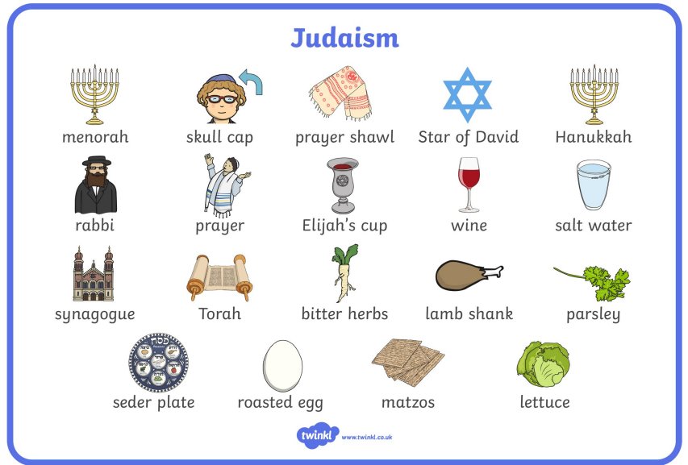

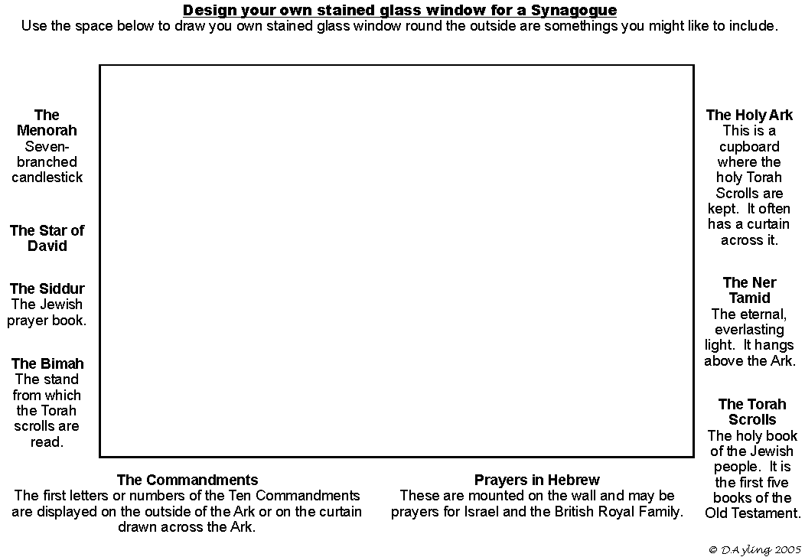

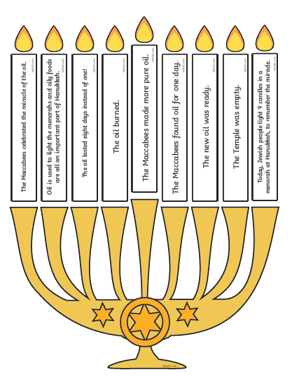
Cut out the candles and then place them in the correct order of events.



