
Monday
Count the number of objects in tens then ones. Show it in jumps on the number line. Write the number.

Count in tens then count on in ones!

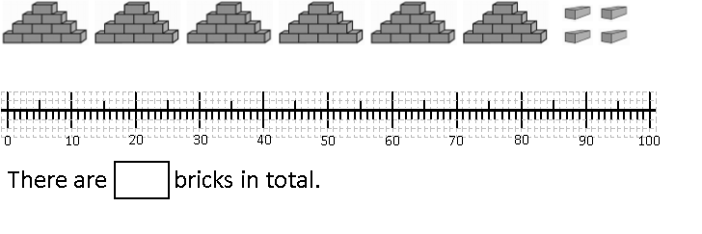

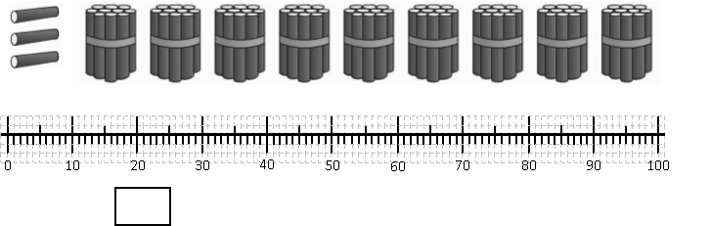
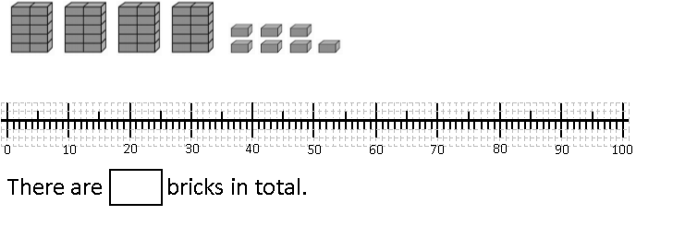

Tuesday




 | 
7 | 2

Tens | Ones
7 | 2

DD

Tens | Ones

Tuesday

Tens | Ones

Can you draw your own representations?

32

24

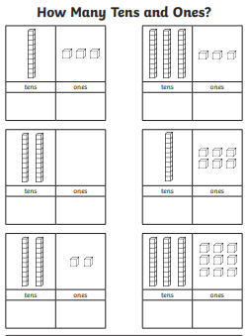
Wednesday

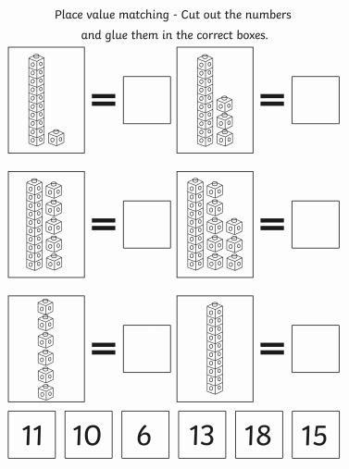
Thursday

