Home Learning – English task break down
Monday:
Dictation: adult support required
Read the following text to children but do not show them. Read it through once and then read it through again. Ask the children to copy the sentences as you read them. This is good practice to ensure that they are listening for punctuation and sounding out words they are unsure of.
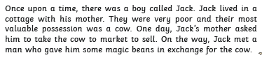
Check your work: independent
You can now read the text below yourself.
Use a colour pencil to make any corrections to punctuation.
If you have made any spelling mistakes, please correct these and then write down 3 words that you misspelt (if you made any mistakes) in the back of your book. You do not need to correct any spelling mistakes in words that are more than 6 letters long.
Word Find: Independent
Now read through your work again. Firstly, underline any adjectives (describing words) you can find and then circle any verbs (doing/action words).

Tuesday:
Up-level sentences: independent/adult support
Re-read your sentences from the beginning of the story.
Firstly, is there anything you could add to make the sentences more interesting? You do not need to rewrite the sentences yet, just write in improvements around them using a coloured pencil.
Use a thesaurus and see if there are any words you could improve. You can add these words into your sentences or you can write them underneath if you are running out of space.

Time adverbials: independent
First, copy ten of these time adverbials into your workbook:
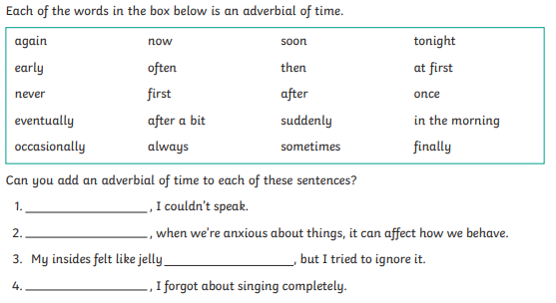
Now re-write these sentences, adding in an appropriate time adverbial. After each sentence, check that it is correctly punctuated.

Wednesday
Time adverbials: independent
Write out the sentences below and underline the time adverbial phrases using a coloured pencil.
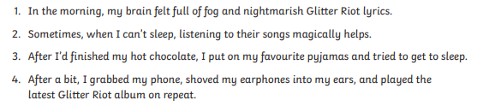
Edit and improve: independent
Now use your ‘Jack and the Beanstalk’ sentences from earlier in the week. I would like you to re-write them with your improved vocabulary and see if you can add any time adverbials.

Remember to use your ‘think it, say it, write it, check it’ strategy for each sentence.

Thursday:
Word find game: adult support required
Children are to read the rest of the text. (see next page)
Give your children 2 minutes to try to find ten words from the text. You could use the following words (or find your own):
Cottage, return, angry, climbed, reached, hid, fell, cupboard, followed, happily.
If you are able to print the page, you can do that and then tick words off as you find them. If not, you could write the ten words down before you start, and put a tick next to each one as you read through the text.
Comprehension: independent
Work through the comprehension questions (following pages). Write your answers in your book in full sentences.
When you have finished, check that every sentence is punctuated correctly.

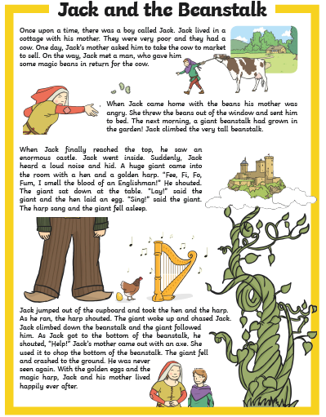

Comprehension questions:

1. What did Jack sell?
2. What did Jack get in return for the cow?
3. What grew in the garden?
4. What did Jack see once he climbed to the top of the beanstalk?
5. What did the giant shout when he came into the room?
6. What did Jack do when he heard the giant?
7. How did the giant fall asleep?
8. What did Jack take from the giant?
9.How did they get rid of the giant?

Friday:
What if: Adult supported discussion. Independent writing.
What would happen if the story was different? I will give you 3 options of how the story could be different. I want you to choose one and then re-write the story with this change.

1. What if a dragon guarded the castle instead of a giant?
2. What if Jack hadn’t been able to hide when the giant appeared? How would he have escaped?
3. What if Jack’s Mother hadn’t been able to chop down the tree in time? How could they have gotten rid of the giant?
Be as imaginative and creative as you like but remember, it must make sense!!

Use your ‘think it, say it, write it, check it’ strategy. Try to include as much of the success criteria as you feel confident with. Everyone should be able to reach the 1* criteria.

Success Criteria:
*
Joined up handwriting
Sentences make sense
Full stops and capital letters in the correct place.

**
Exciting vocabulary (adjectives and verbs)
Extended noun phrases
Time adverbials

***
Paragraphs
Subordinate clauses
Showing-not telling sentences.
Time adverbial sheet answers (Wednesday):
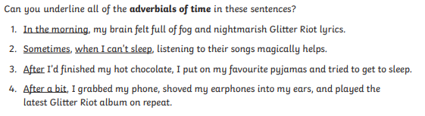
Comprehension question answers (Thursday):


