Home Learning – Maths
Timestables:
Children should practise their times tables daily.
Using the following link, you can create a ‘times tables’ practice sheet.

http://www.timestables.me.uk/printable-pdf-quiz-generator.htm

Children should practise their 2, 5 and 10 times tables this week (including the ‘divide by’ questions). In class, we use sheets that are 40 questions long. You may want to print these out. Alternatively, you could write up questions or work through them verbally.

Monday:
Number bonds:
Please complete the following calculations. The whole is always 100. For example, 1+99=100. For each question, draw a bar model and a part whole and then write the following sentences filling in the gaps.
The whole is 100. The parts are ____ and ___.
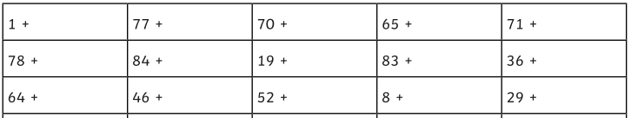

Tuesday
Please complete the following questions. Use column method of addition. Then use a place value chart and dienes bocks to check your answers.
These questions may contain ‘regrouping’. (We used to call this carrying)
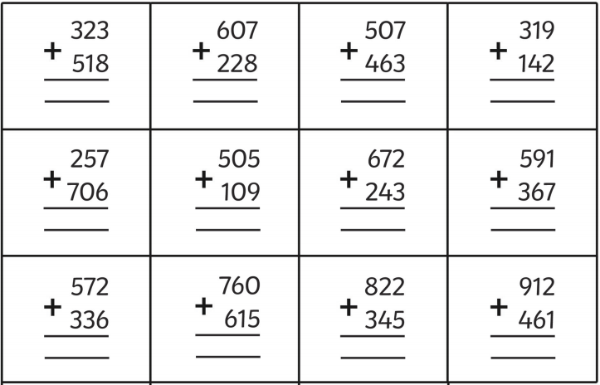

Wednesday
Answers/working out can be recorded in exercise books
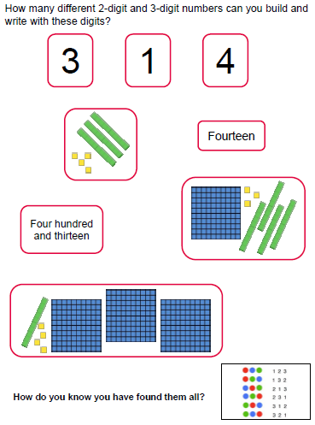

Thursday
Answers/working out can be recorded in exercise books
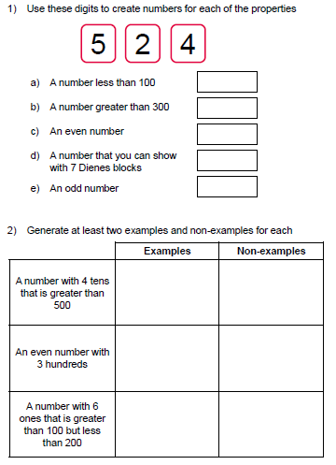

Extension:
Look at the questions for section 1. Can you find any other solutions?

Friday:
Answers/working out can be recorded in exercise books
You will need to write sentences to explain what is the same and what is different. There may be more than one similarity or difference.


