


Newsletter

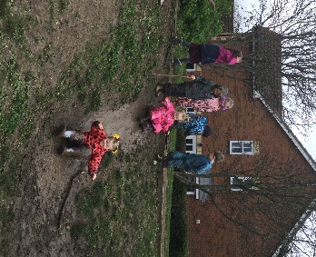
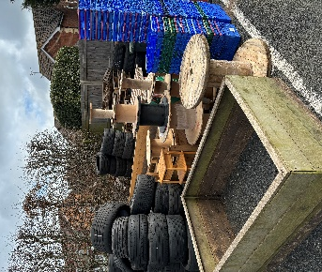
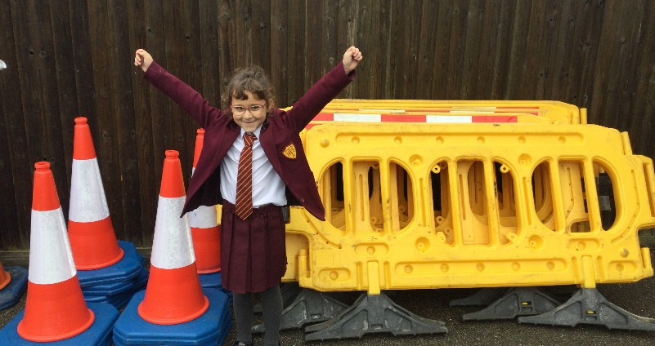

What an exciting few weeks we have had here at RHT! We would firstly like to say a big thank you to all those of you who have recently dropped off and donated traffic cones, road markers, water butts, planters and cable reels. The pile of bits and bobs is growing and we cannot wait to put these to good use over the next few months.
Over the last week or two, the children have thoroughly enjoyed climbing trees and making dens. Here are just a few of their happy faces. We have also had lots of lovely conversations around our muddy play areas - Johan in Year R told us he, “had the best school day ever” after jumping in the mud and playing with his friends in the rain!

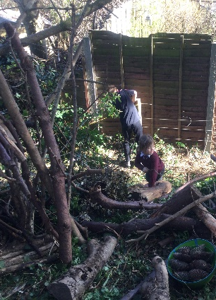
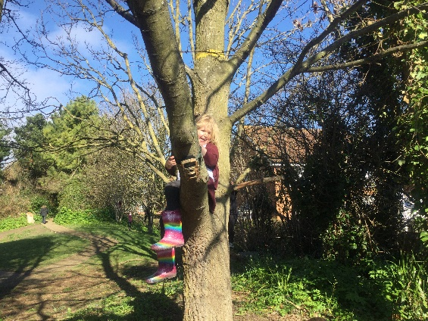
Wet Weather Clothing

As we draw to the end of another busy term, all children will be sent home with their wet weather clothing (puddle suits and waterproofs) next week. Please can we ask that these are returned on Monday 15th April. Can we also ask that children have a spare pair of socks and/or tights in their bags for any wet feet!

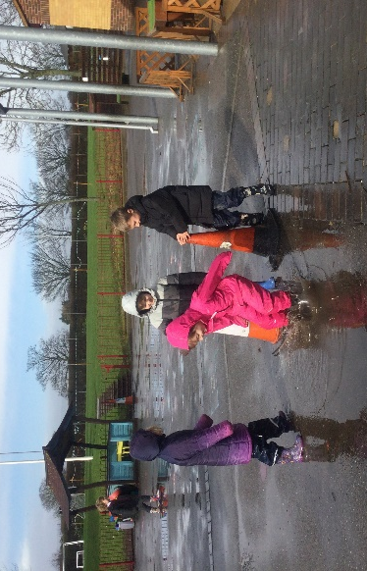
Cosy Cabin
The recent spate of wet weather has spurred us on in our search for ‘dry’ alternatives for children when it is wet outside. Children have been putting their thinking caps on and have come up with some brilliant ideas for raising money for a Cosy Cabin, which will hopefully come into effect next term. Watch this space!
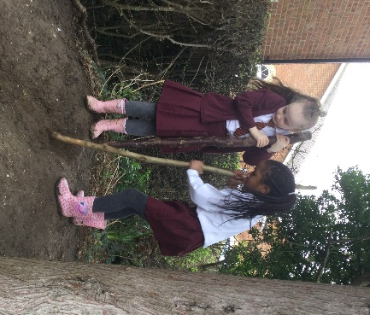

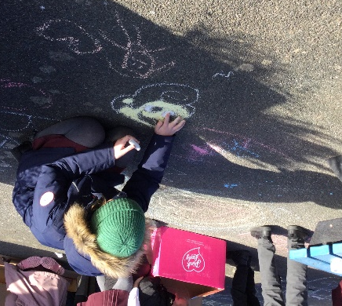
Our Big Ask
We are also in desperate need of someone who can help us with our outdoor fencing. Over the coming months we would like to move / remove some of the fencing around our school field. If there is anyone within our school community that has experience and knowledge in this area, and wouldn’t mind coming to look and talk about what is and isn’t possible, we would be very grateful! Please get in touch with the school office if you think you can help.

