Home learning – Day 1

Maths
Please follow the link to the Oak Academy lesson on Roman Numerals. It has been a while since you will have looked at them, so please do the introductory quiz, then watch the video and work through the independent task. Mark this yourself!
Then let me know how you do on the final quiz! This is revision, but it has been a long time! Just try your best!
https://classroom.thenational.academy/lessons/investigating-roman-numerals-up-to-1000-61k32r

Spellings:
You can find your spellings for this week in your spelling books or on Showbie! Spend 20 minutes practising these. You could use any strategy you like… pyramid, quickwrite and using coloured pencils for the tricky parts of the word.

English:
Complete the comprehension questions on the next page based on the two characters.

Topic:
Use the attached ‘Darwin’s Delights’ home learning sheet. Select one of these and complete it. You can be as wild and creative as you like! If you go big, and your project work might take more than one day, you can continue with this tomorrow!

The Monster’s Ring
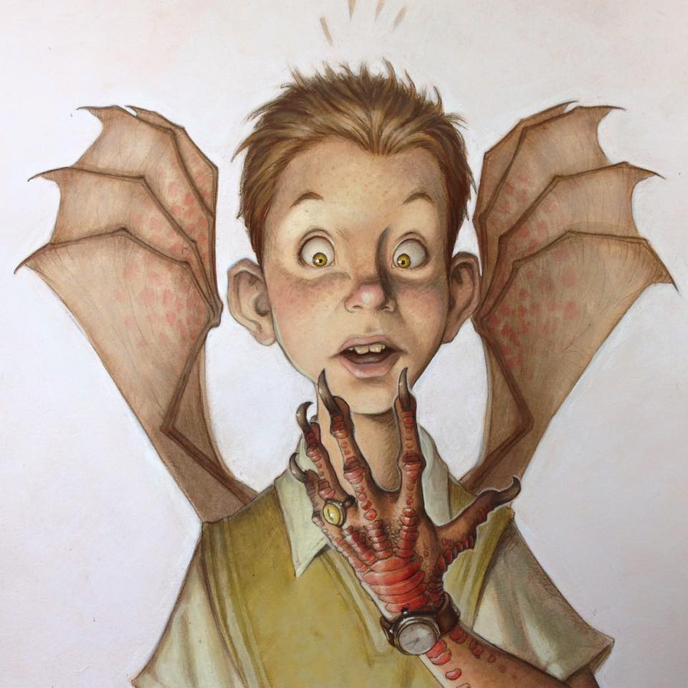
- What is ‘The Monster’s Ring’?
- Is the boy wearing it?
- What is special about it?
- What has happened to the boy?
- Which change happened first?
- Will he always be this way?
- How is he feeling?
- What might he be thinking?

Lord Downey

• What do you know about this man? What evidence do you have?
• What is he holding in the bag? Why is it glowing?
• Why is he wearing gloves?
• Where is he?
• What is his job?
• Does he remind you of anyone?
• Would you like to meet him? Why?

Final Question:
Which is the better character to use in a story? Explain why.

