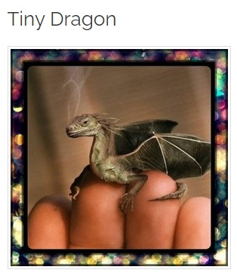
Use your imagination …

Where is it from?
Why is it so small?
Are there more like him or her?
Where does he or she live?
How will you look after it?
Will you tell it a secret or tell someone?
What is it called?
Is it magic? What magic can it do?
- Thinking about each question and using your imagination, write down your thoughts about the tiny dragon.
- Complete the word bank describing the dragon.

scales | claw |  |  | wings
 |  |  | magic
 | smoke

Day 2: Write a descriptive story about the tiny dragon
Success criteria:
- Descriptive language.
- Read through your writing to check it makes sense.
- Full sentences with capital letters and full stops.

