Singapore
Flights: £552 return Singapore Airlines from London Heathrow
£1,103.58

Cuba
Self-catering - Casaverde is a guest house in the centre of Havana:
£36 per night/bedroom
- Villa in the heart of La Havana, sleeps 4: £105 per night
Or £727 weekly rate

New Zealands Marlborough and Nelson
3*** hotel Chateau Marlborogh, Blenheim; £103 per room per night
4**** hotel Marlborough Vintners Hotel, near Blenheim; £129 per suite per night
Self-catering Glenfern Villas, Franz Josef; £85 per villa per night
All inclusive

New Zealand South Island
Flight Details
Air New Zealand flights to Auckland, via Los Angeles, depart daily from London Heathrow. Onward flights from Auckland to Wellington, Christchurch, Queenstown and Dunedin are operated by Air New Zealand.
Flight Upgrades
Premium Economy available from £695 supplement per person each way. Business Class is available from £1,629 supplement per person each way.
Flight Time
Approx 26 hours to Auckland.
Approx 1 hour Auckland to Wellington.
Approx 1 hour 20 min Auckland to Christchurch.
Approx 1 hour 50 min Auckland to Queenstown.
Approx 1 hour 55 min Auckland to Dunedin.
Language
English
Currency
New Zealand Dollar
Key Events
New Zealand may have varying public holidays and special events – too many to list! Shops and businesses may have limited opening hours and excursions may not always operate.
Time Difference
GMT +12 hours (Apr-Oct), +13 hours (Nov-Mar)

Barbados
Flights £616 return British Airways from Gatwick
All inclusive - 3*** Butterfly Beach Hotel with Virgin Atlantic;
10 days; £788 per person
7 days; £751 per person
- 5***** Fairmont Royal Pavilion
10 days; £2475 per person
7 days; £1809 per person
3*** Beach View £100 per night (Paynes Bay)

Bali
Flights
3*** hotel Villa Balquisse, Jimbaran £118 per night
5***** hotel Jamahal Private Resort & Spa £184 - £573 per night
Self-catering Villa Merak, South Bali 116 Euros per person per night
All inclusive £1023 per person Segara Village (7 nights) in Sanur Beach

Fiji
Flights £1,105.64 return Cathay Pacific Airways from Heathrow
Out LHR: Wed 18/7/12 20:15
In: Fri 20/7/12 07:05
Return: 28/7/12 08:25 In LHR 29/7/12 05:40

General information

THE COUNTRY
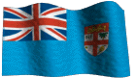Fiji is a 333 ISLAND nation, with 7,055 sq.miles of land occupying an ocean area of 426,000 sq. miles, first charted by American Commodore Wilkes in 1839.
The Fiji Islands are generally divided into three groups: the central islands including Viti Levu (4,112sq.miles) and Vanua Levu (2,432sq.miles) comprise the largest and most fertile land mass and population bases. The Lau (or Eastern) Islands are small, lying east of the main islands as far as Tonga.

Language
English is the official language. The widely used Fijian language has many dialects and is commonly known as Bavan Fijian.

Religion
More than half of the population are Christians (52.9%). The rest is made up of Hindus 38.1%, Muslims (7.8%), Sikhs (0.7%), and others (0.1%).

Geography
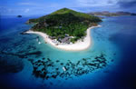There are three types of land formation making up the Fiji Islands: volcanic, coral and limestone. The bigger islands are primarily volcanic. While there has been no recorded activity in modern history, the presence of hot springs indicate that the fires of creation are not fully extinguished. The practical Fijians use them to cook or for a warm bath.
Fiji is mountainous with several peaks exceeding 3000 ft and one, Mt. Victoria on Viti Levu, of over 4341 ft. With 112 inches of annual rainfall, the windward (Eastern) side of the Fiji Islands is remarkable, known among tropical nations for its fertile plains and valleys of the richest alluvial soil. Fiji is richly endowed with fresh water, its most important rivers being the Rewa, Navua, Sigatoka, and Ba.

Climate
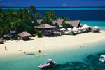Fiji enjoys a tropical oceanic climate, with gentle trade winds tempering the heat and humidity. Each of the main islands divided by mountain ranges has a "wet" side to the south and east, and a "dry" side to the north and west. Resorts tend to line the west and south coasts of the larger islands.
Seasons are reversed south of the equator. Summer months (November-April) have the greater rainfall, while winter (May-October) is drier. Temperatures range from an average of 75° Fahrenheit in July-August to 80° Fahrenheit in December-January.
Fiji lies in the path of hurricanes moving south from the equator in the months of November-April. Only four severe storms have hit the islands in the last 20 years.

Maldives
Flights £592 return Qatar Airlines from Heathrow
3*** hotel paradise island resort and spa £98 per night
5***** hotel Hilton Maldives £153 per night
Self-catering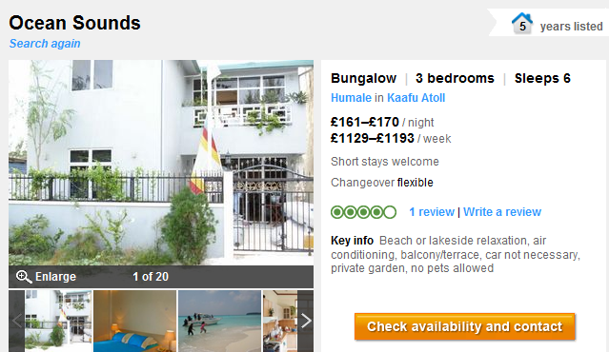
All inclusive Centara Grand Island Resort & Spa 5**** £2340 per person

Japan Tokyo
Flights £875 return Virgin Atlantic from Heathrow to Tokyo 11h44m
3*** hotel Shinjuku Prince Hotel £76 per room per night
5***** hotel Park Hyatt Tokyo £296
Self-catering 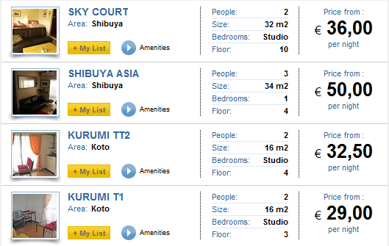
All inclusive £1494 per person for 7 nights

Island | Flight times from London - direct | stopover
St Lucia | 8h 45 min | 10h 45 min with stopover in Antigua  Antigua – St Lucia: 45 min
Barbados | 8h 30 min | From Miami: 3h 30 min  From Toronto: 4h  New York: 5h
Cuba | 9h 40min | From Miami 35 min
Zanzibar | 10h 15 min | London – Nairobi 9h  From Nairobi 75 min
Maldives | 13h | From Birmingham 13h 20 min
New Zealand | To Auckland  24h 55min | 11h 30 min to LA  10h 30 min to Auckland
Japan | 11h 45min | London – Dubai 7h  Dubai – Japan 10h
Seychelles | 10h 30min | London – Dubai 7h  Dubai – Seychelles 4h
Singapore | 13h 45min | London – Hong Kong 12h 10min  Hong Kong – Singapore 3h 20min
Hawaii | 17h 20 min | London – Los Angeles/San Francisco 11h 10 min  From there to Honolulu 5h 30 min
Borneo | 12h 30min | London – Kuala Lumpur – 13h 30min  Kuala Lumpur – Kota Kinabalu 2h 35 min
Bali | 16h 25 min | London – Hong Kong 12h 10min  Hong Kong – Bali 4h 30min
Mauritius | 11h 45 min | London – Johannesburg 10h 50 min  Johannesburg – Mauritius 3h 45 min  London – Nairobi 9h  Nairobi – Mauritius 6h
Madagascar | 13h 15 min | London – Paris 1h 15 min  Paris – Madagascar 10h 55min
Sri Lanka | 11h 15min | London – Dubai 7h  Dubai – Sri Lanka Colombo 4h
Fiji | 27h 45min  (no direct flights from UK) | London – Los Angeles 11h 5min  Los Angeles – Nadi 11h 40min
Dominican Republic | 9 hours 15 min | London – Puerto Plata 9 hours 15 min  London – Miami 9 hours 35 min  Miami – Punta Cana 2 hours 35 min

