Art and Design Activity 6
Building Art
Please remember to keep any artwork safe so that it can be displayed, in the future, on the hall display boards.
Have a look at some of the ideas below as a starting point for your own art.
- Draw some of the houses you can see from your window and colour them in bright colours.
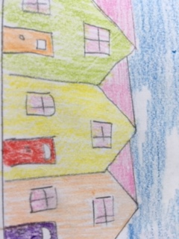

- Create something similar, but using bits of coloured paper and card to create a collage.

- Use packaging, like a toothpaste box, to create a 3D building.
a) Carefully open the glued side of the box. Use the inside to draw on windows and doors.
b) Cut the roof-line at the top of the box
c) After painting it, re-glue the box with your artwork on the outside.
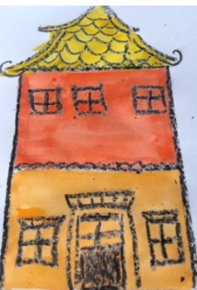
- Use a wax resist technique. Paint the sky on a piece of plain paper.
- On a 2nd piece of paper, draw buildings using a black, wax crayon.
- Paint over the buildings in quite watery paint.
- When dry, cut around the outside of the buildings and stick these onto the sky background.

- Use a one-point perspective to draw a street of houses.
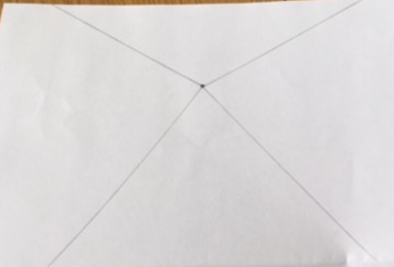

Start by marking the “vanishing point”

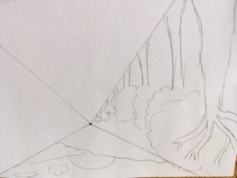

Draw in the background in the top triangle.
Add in a row of trees in the left triangle. The trees need to become smaller in size and thinner as they go towards the vanishing point.
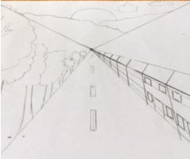
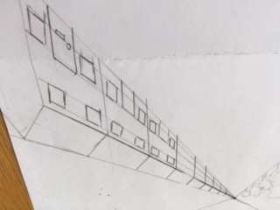
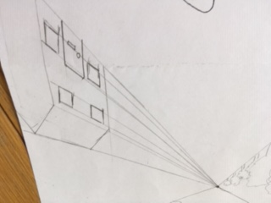
Draw a house in the right hand triangle. Draw straight lines from the vanishing point to parts of the house – roof, top and bottom of windows, the door. These will become guidelines for drawing the same parts on the other houses.

Once the row of houses is complete, add in road markings and perhaps add some cars.
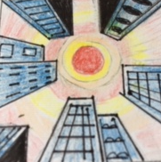
Lastly, colour in your picture.

You can use a single vanishing point to create unusual images like this one. It is drawn from the perspective of a person looking up towards the sky, as they stand surrounded by buildings.

