Art and Design
Activity 5 – Doodle Art
Please remember to keep any artwork safe so that it can be displayed, in the future, on the hall display boards.
Here are a few images to give you a starting point, then doodle away!

- Take your pencil for a walk
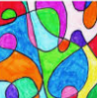
Just draw a continuous line, which overlaps at several points on the paper, then colour in the shapes that have appeared.
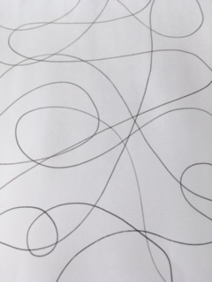

- Draw a football and draw different doodles inside each of the hexagonal shapes.
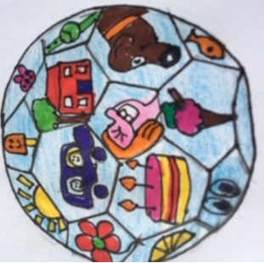
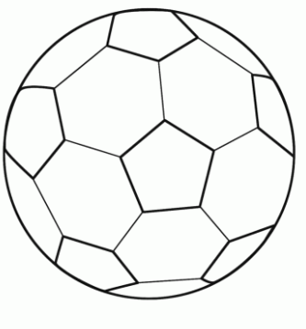

- Draw around your own hand, then divide it into small shapes and add patterns, which you can later colour in. (See below)

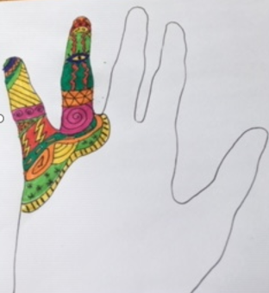
Continue to add patterns and colour until the whole hand is complete.

- Grow a Doodle
Start with a small doodle in the centre of your page. Add further doodles around this to create a much larger doodle. You can leave this as a black and white piece of art, or colour it in.
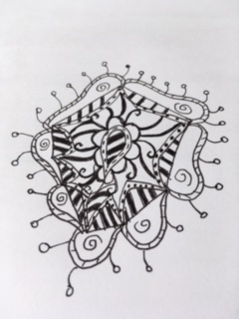

- Draw a mixture of rounded and straighter edged shapes. Add some detail in the centre of the shapes with a black felt-tip pen, then colour in the shapes.
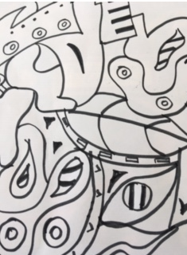
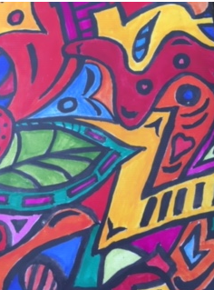

- Creature Doodles
Draw a simple creature shape like a snail, chameleon, cat or snake, then add different patterns. You can keep this as a black and white doodle or add colour to it.
(See example below)


