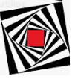
Art and Design
Activity 4 – Optical Art
Please remember to keep any artwork safe so that it can be displayed, in the future, on the hall display boards.

Optical Art (often shortened to “Op Art”) uses shapes, colours and patterns in ways to create images that sometimes look as if they are popping out of the artwork piece. Sometimes the images look as if they are moving or blurring. Other pieces of Op Art make you think there are curves on the page, when all the lines are actually straight, or are designed to give a 3 dimensional effect.
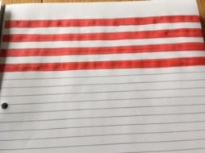
(Parents may need to help our youngest children with these.)
- Pop Out Shapes

- Use lined paper and colour in alternate lines.

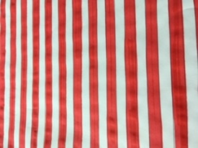
b) Colour 2 complete pieces of paper like this.

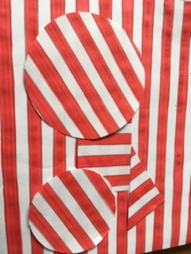
- On one of the sheets, draw the shapes you wish to use.
- Cut the shapes out and arrange on the full, lined piece of paper.
- The shapes should “pop out” of the page.

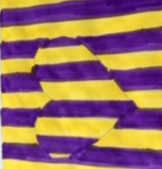

- Undulating Shapes.

- Start in the centre of a square or rectangular piece of plain paper.
- Draw lines, in pencil, from the centre to the outer edges.
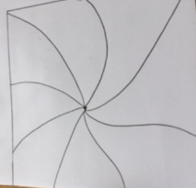

free hand

- OR, use a ruler to draw lines from the centre to the outside edges.
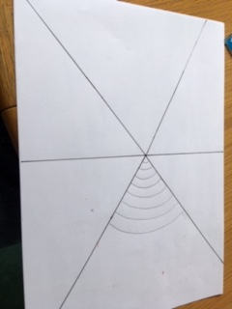
using a ruler

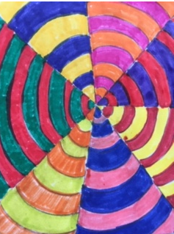
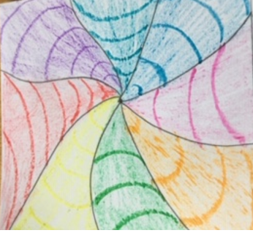
- Draw curved lines of different widths within each segment. You could also try alternating the lines curving downwards or upwards within each shape. Colour the shapes in to finish your artwork.

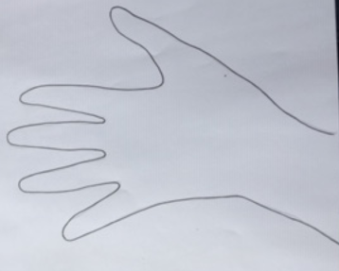
- Creating a 3D Hand

- Draw around your hand on a piece of plain A4 paper.

- Draw a horizontal line from the left side of the page towards the hand.

(Continued below)

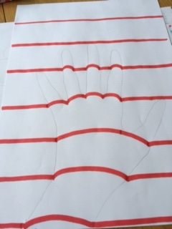
As you reach the hand outline, draw a curved line to the other side of the hand, or across the fingers and thumb, then continue with a straight line to the right hand edge.

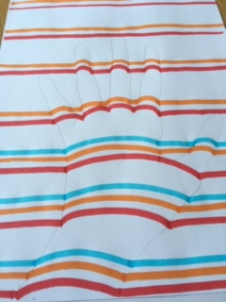
- Continue this, with different colours.

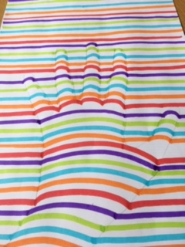
- The finished piece makes the hand look 3 dimensional.

- Try exploring this technique with different drawings, for example a heart or a dolphin shape.

- Disappearing into the Distance.

- Draw a square and mark equal distances along each edge. (1 cm or 2cm intervals depending on the size of your square.) Join the lines to create squares which become smaller towards the centre.
- Draw diagonal lines from each corner to divide the squares into 4 triangles.
- CColour each strip of the triangle a different colour.
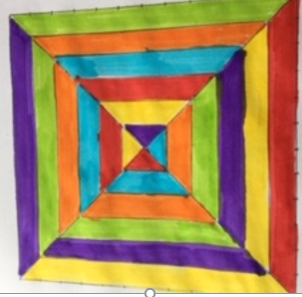
- WVary the order of the colours for each triangle. The effect sometimes creates the illusion of going down a long corridor.

- Creating 3D Sphere Effects.

- Draw different sized circles anywhere on a plain piece of paper.
- Draw slightly curved vertical lines on the circle.
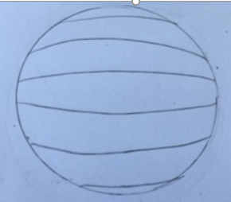
- Draw slightly curved horizontal lines on the circles.
- Colour the sections of the circle in alternate colours.
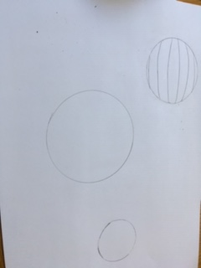
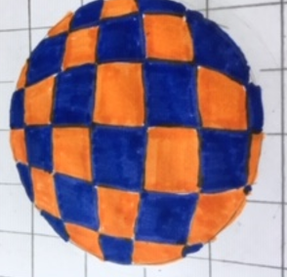
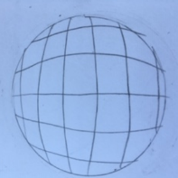

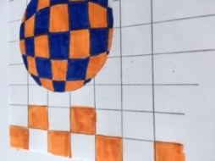
- Divide the background into evenly spaced squares.
- Again, colour thhe squares in alternate co lours.

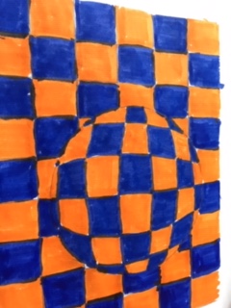
- The finished effect will make the circles look like spheres popping out from the background.

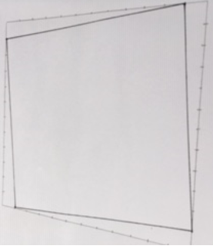
- Curves of Pursuit
- Start by drawing a square and marking 1cm intervals
along each side in pencil. Start 1cm in and draw a line with a
ruler to the next side where 1cm is marked. Carry on all
around the 4 sides.
- Starting at the original corner on the 2cm mark, draw a line to the next side and the 2cm mark there. Continue all around
The square.
- Carry on until you reach the centre of the square.
- Colour alternate sections for an amazing effect, either in black and white or using 2 colours.

- (See the example below.)

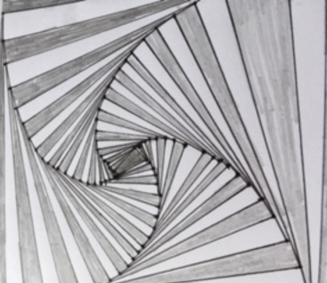
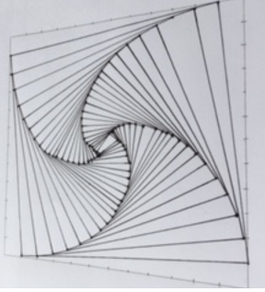
Th

